Azure DevOps

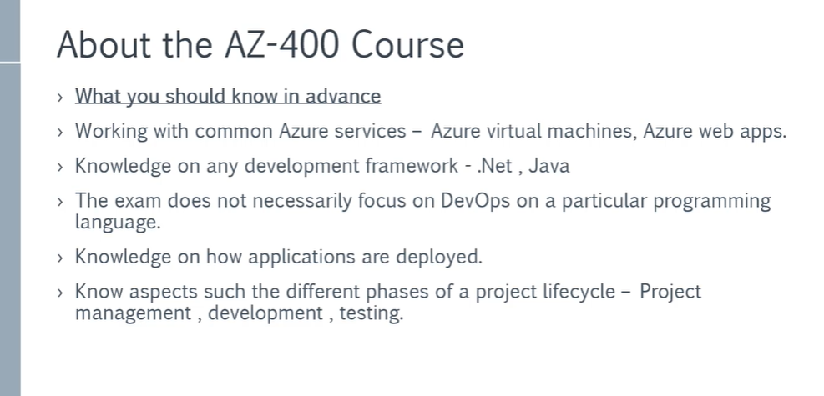

DevOps is the union of people, process, and products to enable continuous delivery of value to our customers.
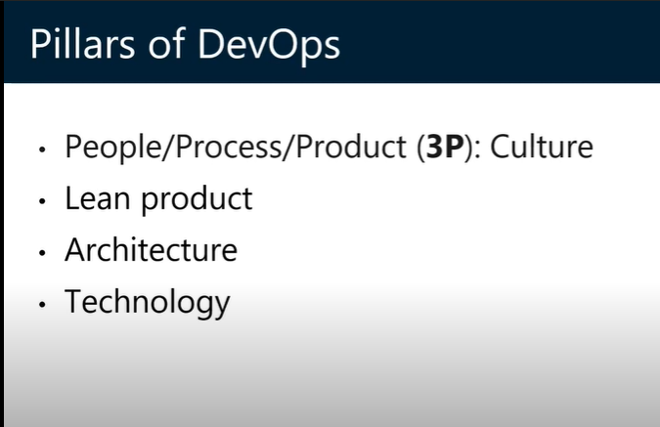
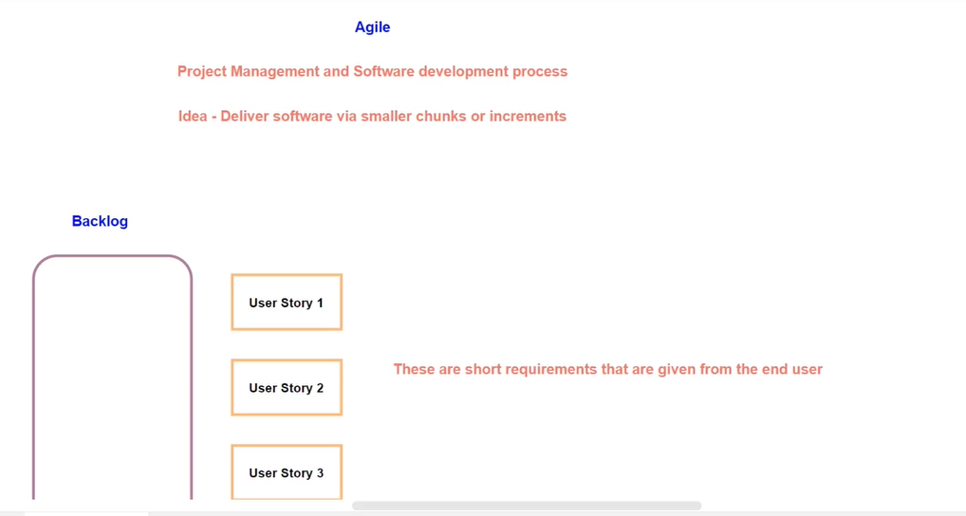

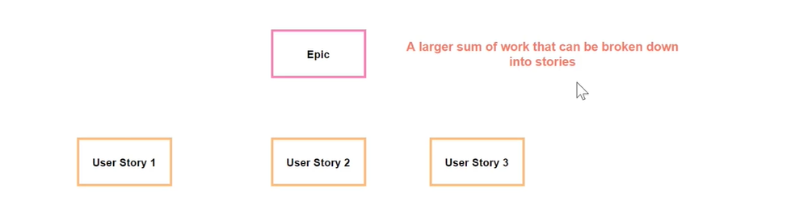
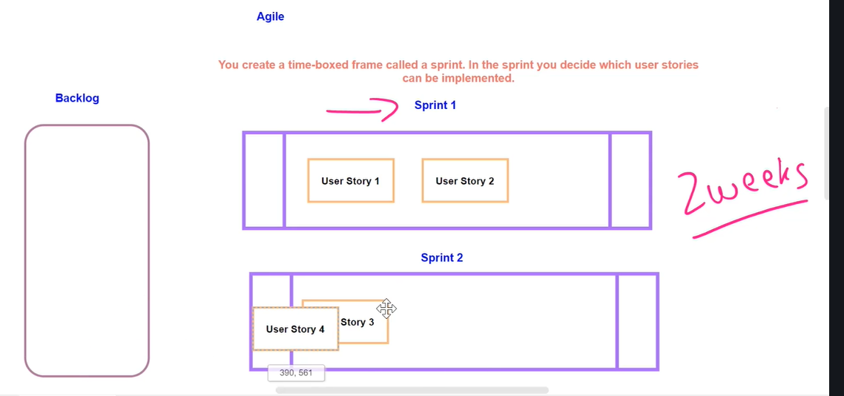

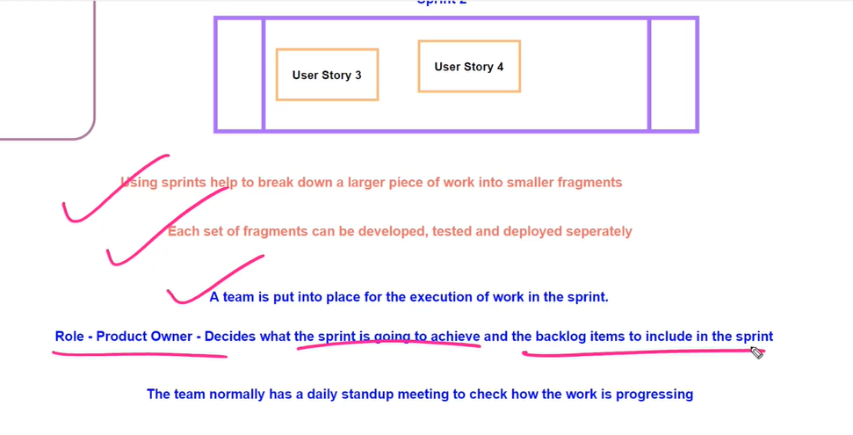

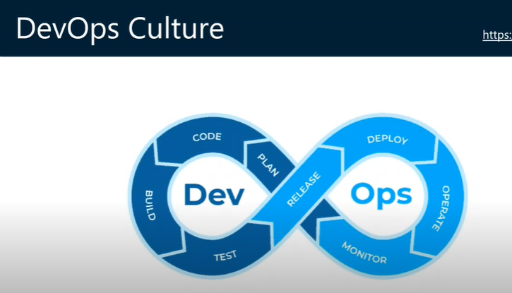

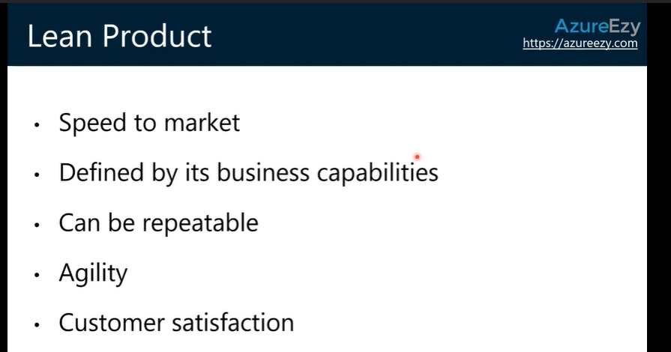

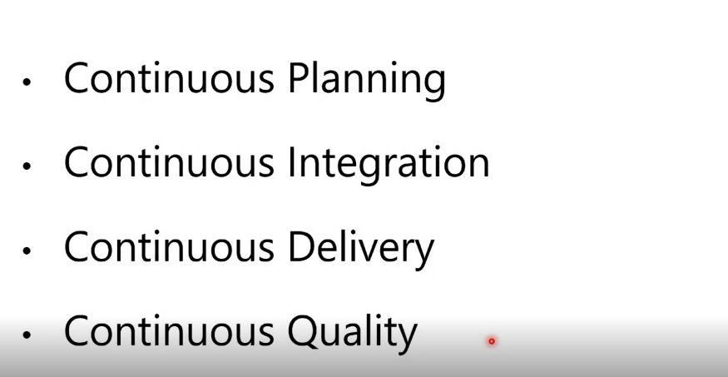

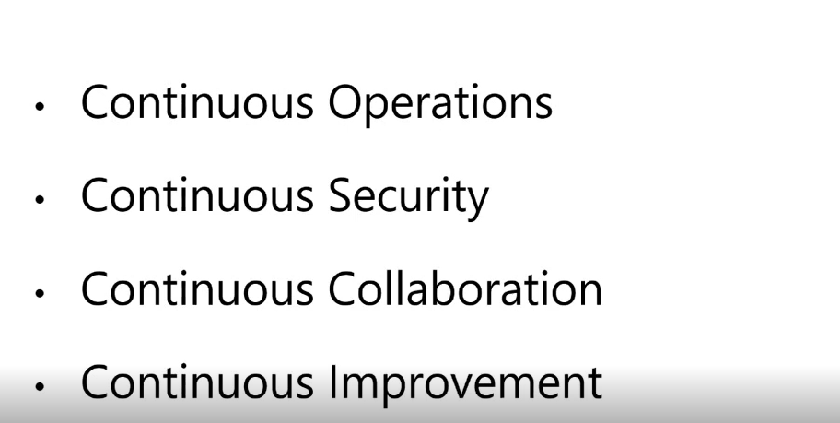

- Agile planning. Together, we'll create a backlog of work that everyone on the team and in management can see. We'll prioritize the items so we know what we need to work on first. The backlog can include user stories, bugs, and any other information that helps us.
- Continuous integration (CI). We'll automate how we build and test our code. We'll run that every time a team member commits changes to version control.
- Continuous delivery (CD). CD is how we test, configure, and deploy from a build to a QA or production environment.
- Monitoring. We'll use telemetry to get information about an application's performance and usage patterns. We can use that information to improve as we iterate.

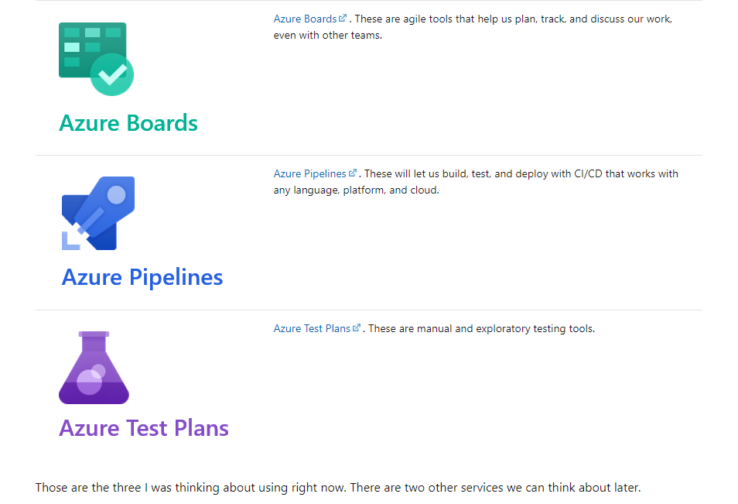

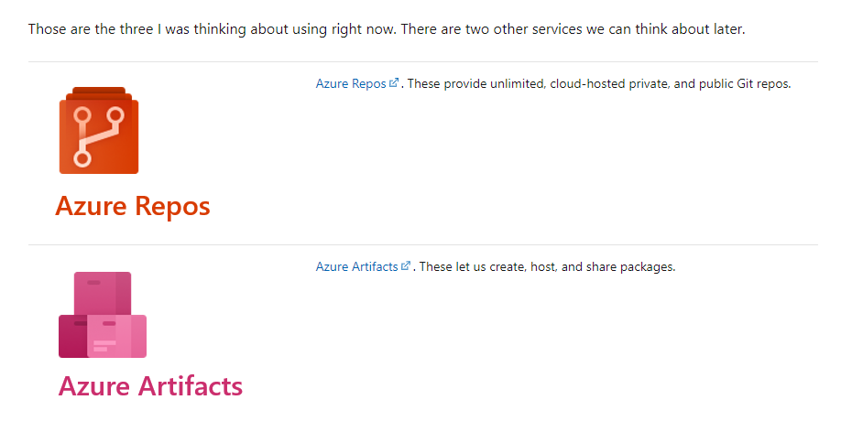

Agile is an approach to software development. The term "Agile" was coined in 2001 in the Agile Manifesto. The manifesto established some guiding principles for a better approach to software development. The manifesto says:
We value:
- Individuals and interactions over processes and tools
- Working software over comprehensive documentation
- Customer collaboration over contract negotiation
- Responding to change over following a plan

An agile mindset helps you respond to changing market conditions and customer needs, instead of simply following a rigid plan.
Azure Boards

Azure Boards is a tool in Azure DevOps to help teams plan the work that needs to be done

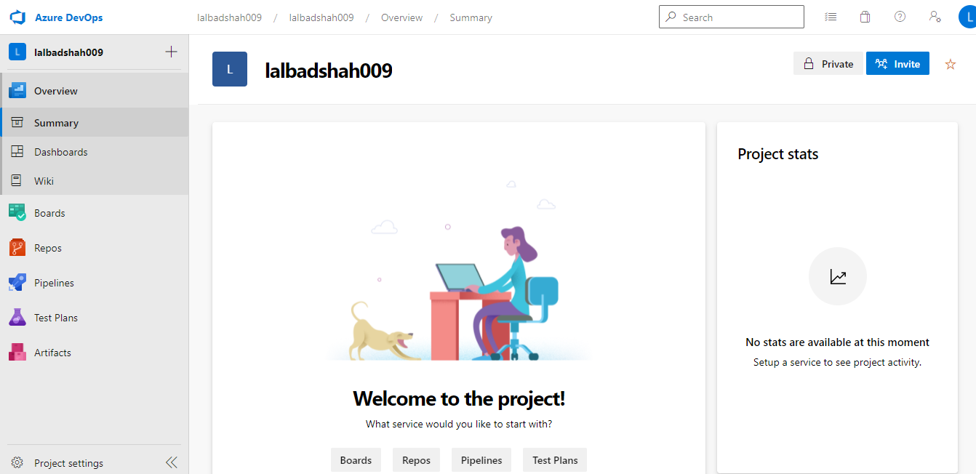

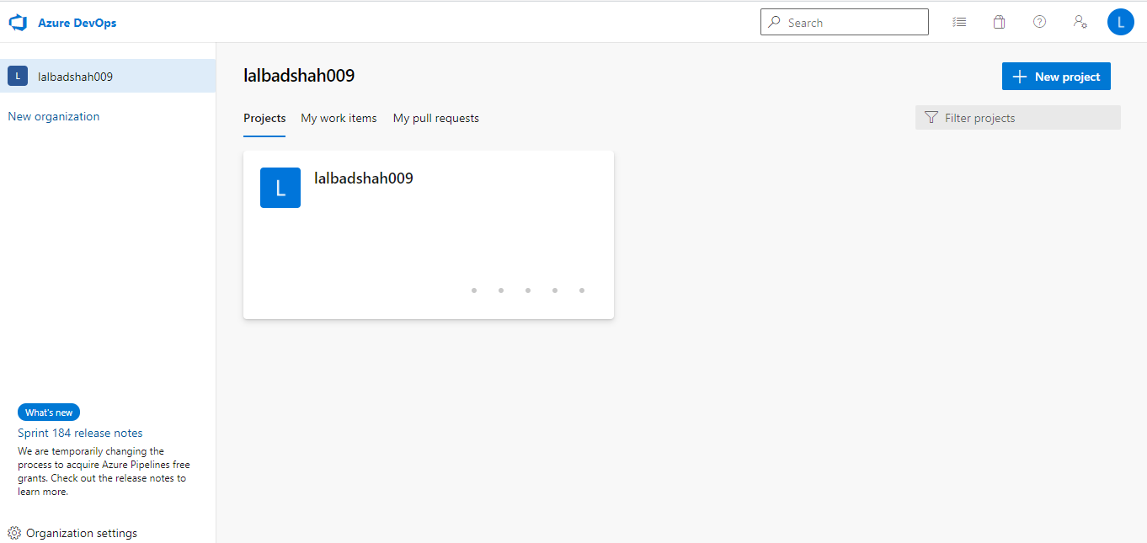

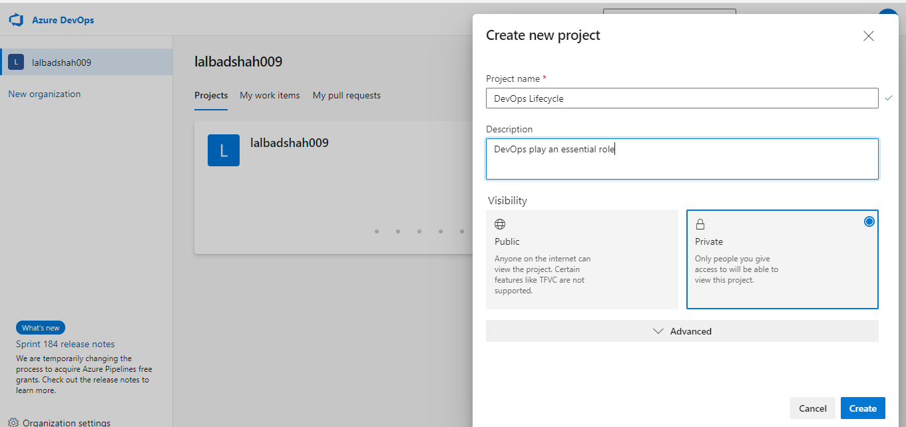

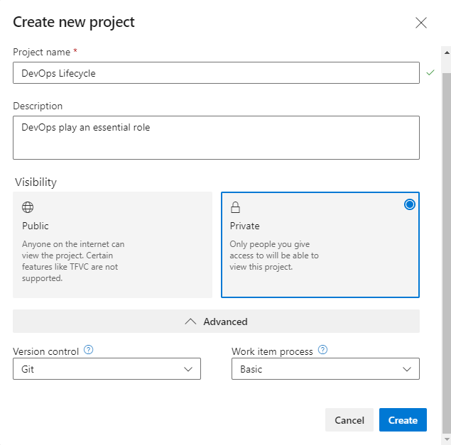

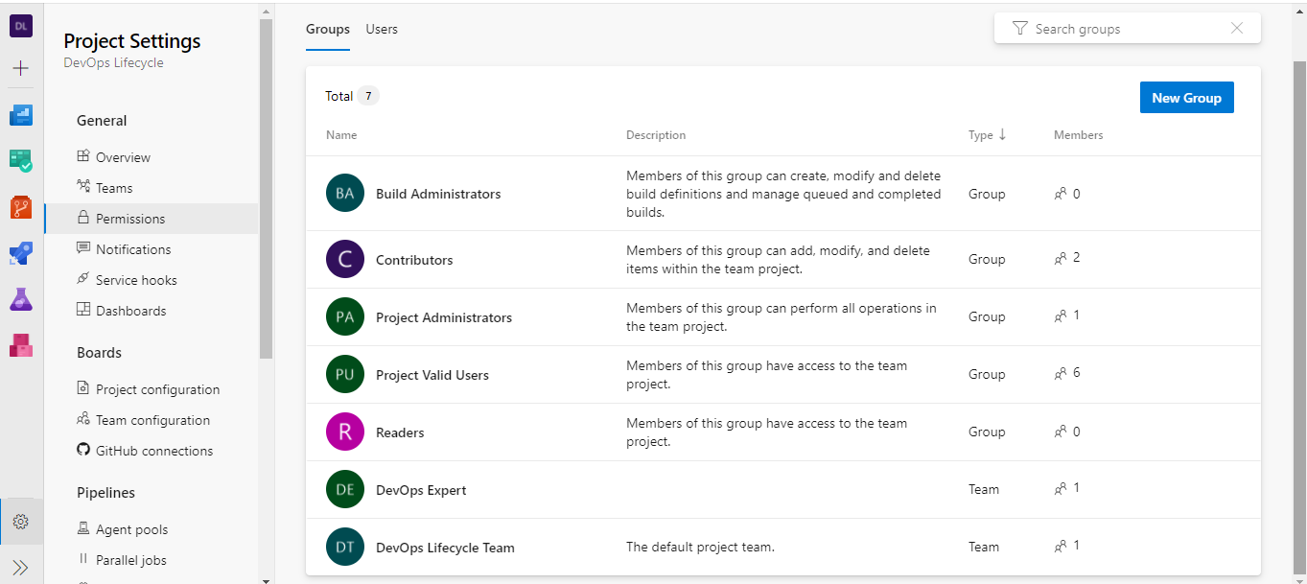

A delivery plan is a visualization of one or more work schedules. It is intended to provide teams and management an overall view of what each team is planning to produce and when. This allows decisions to be made that optimize the investments across the organization.

Delivery Plans is an extension for Azure DevOps that helps organizations plan and review work schedules across multiple teams.

Delivery plans are an effective way to understand how much work a team has committed to within a certain timeframe. This offers a good way to gauge their likelihood to deliver on time.
When is a good time to start using delivery plans?
Creating a delivery plan can be valuable at any point in a project.

Here you create a delivery plan and use it to plan a sprint in Azure DevOps

- Install the Delivery Plans extension.
- Create a delivery plan.
- Add team sprints and milestones.
- Rearrange work items to fit the overall schedule.

Install Delivery Plans

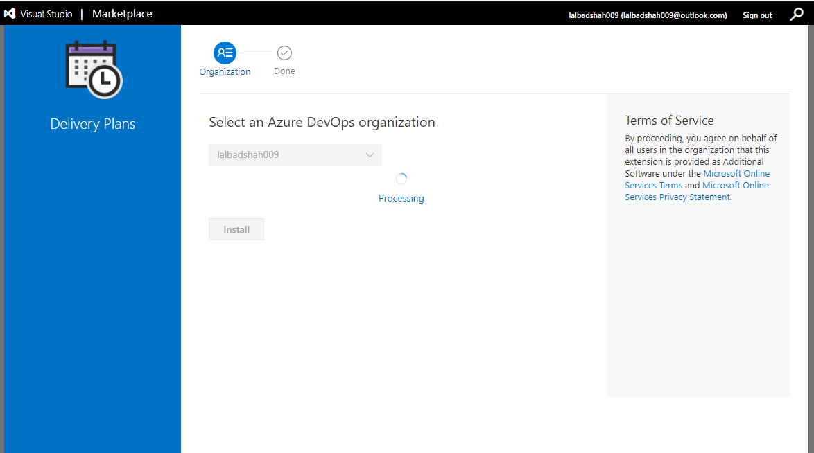

https://marketplace.visualstudio.com/acquisition?itemName=ms.vss-plans

First task
- Integrate Teams and Azure DevOps

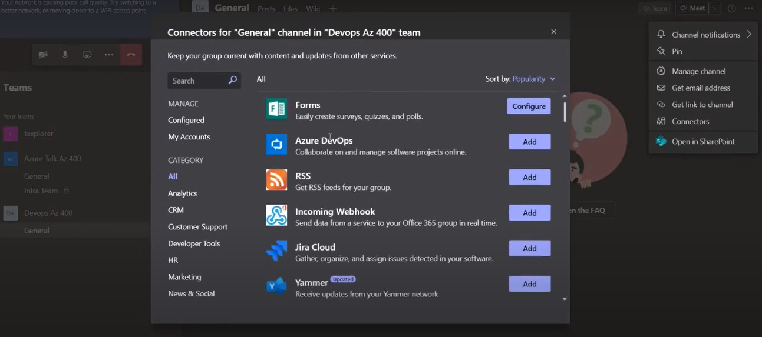
Need to enable Azure DevOps connector

Notification for Work item created

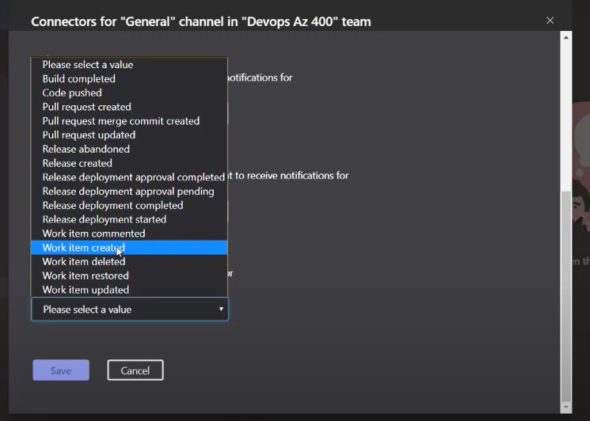

You can configured multiple notification
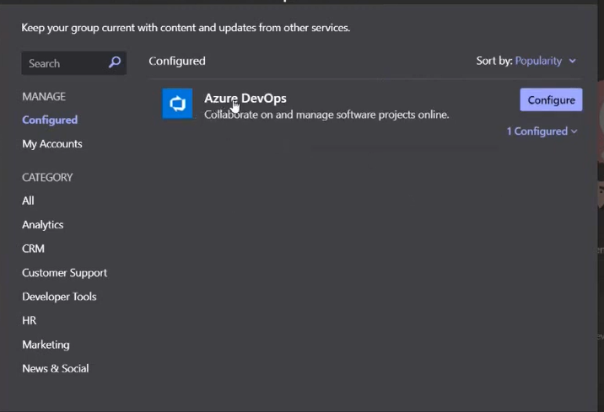

Add Kanban dashboard

New Dashboard
Create Team

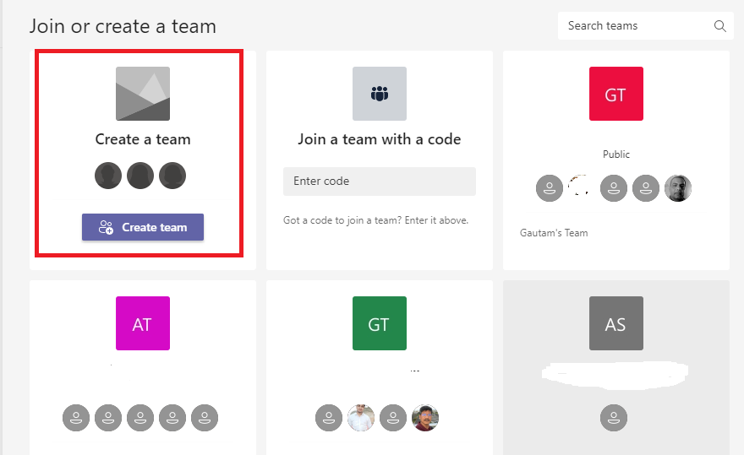

From Scratch
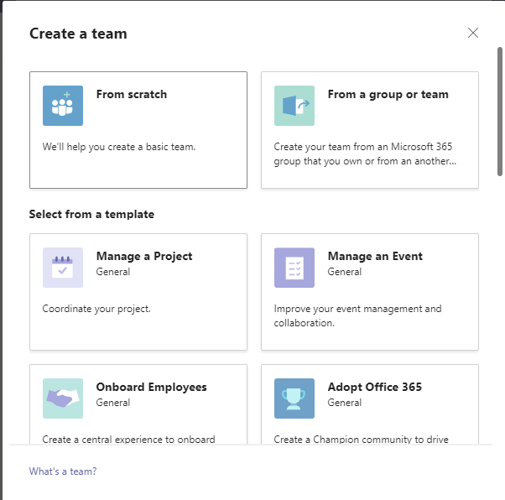

Click on Private
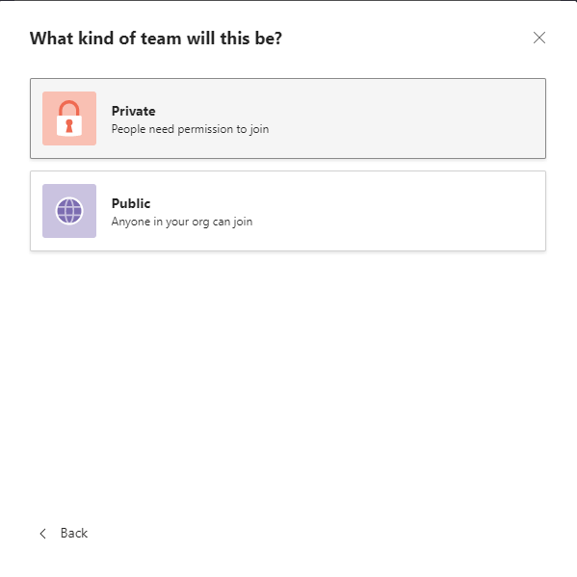

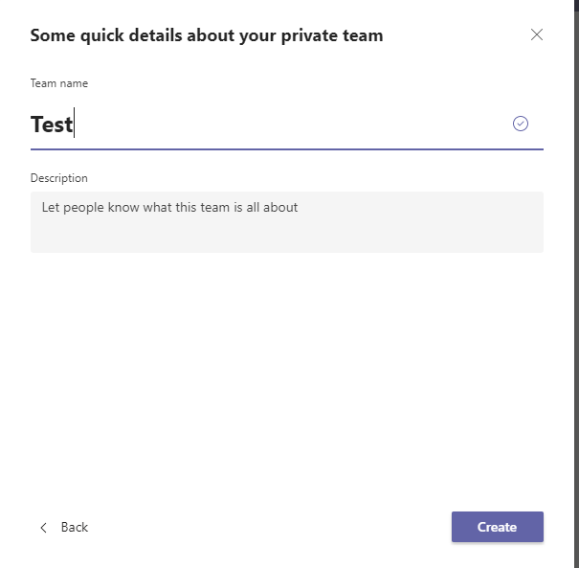

Click on +

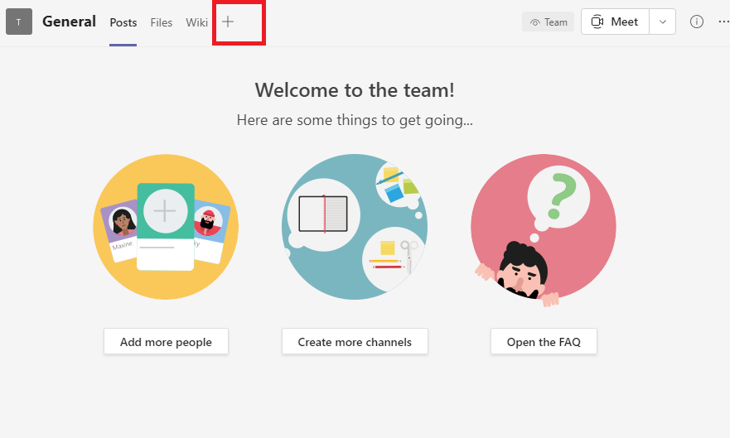

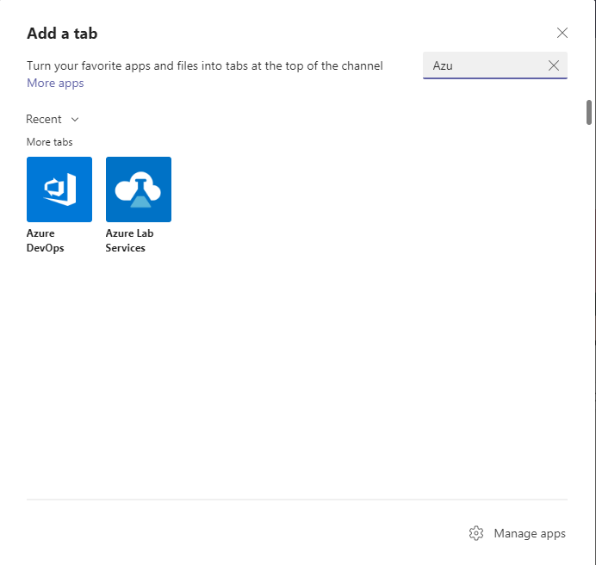

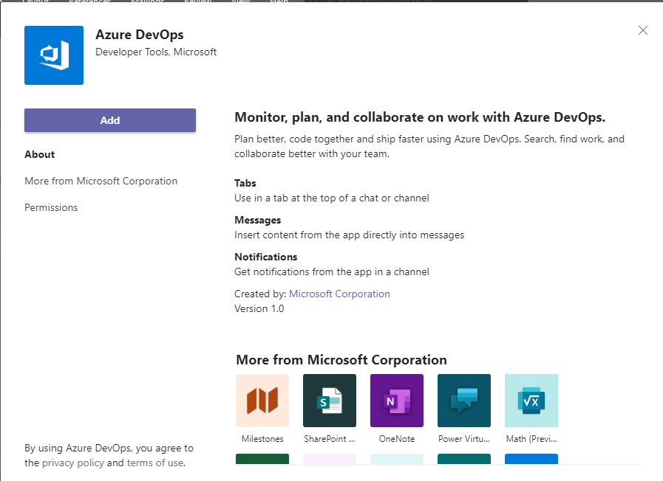

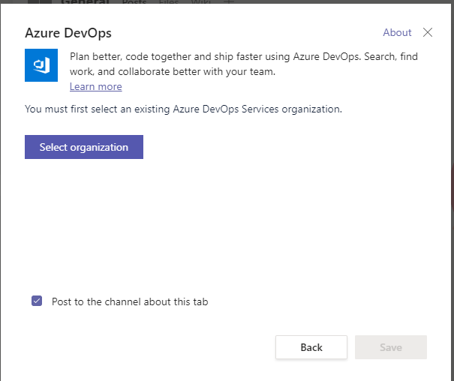

Value Stream Map

The purpose of a VSM is to visually show where in the process a team creates value and where there's waste. The goal, of course, is to arrive at a process that delivers maximum value to the customer with minimum waste. A VSM can help you pinpoint those areas that either don't contribute any value or that actually reduce the value of the product

Azure DevOps is a suite of services that spans the entire DevOps life cycle. Azure DevOps starts with planning and goes all the way through deployment and monitoring. If you already have some pieces in place, you can select which services you want to use. Azure DevOps integrates with many tools, such as Jenkins.
Azure DevOps is a collection of services that provide an end-to-end solution for the five core practices of DevOps: planning and tracking, development, build and test, delivery, and monitoring and operations.

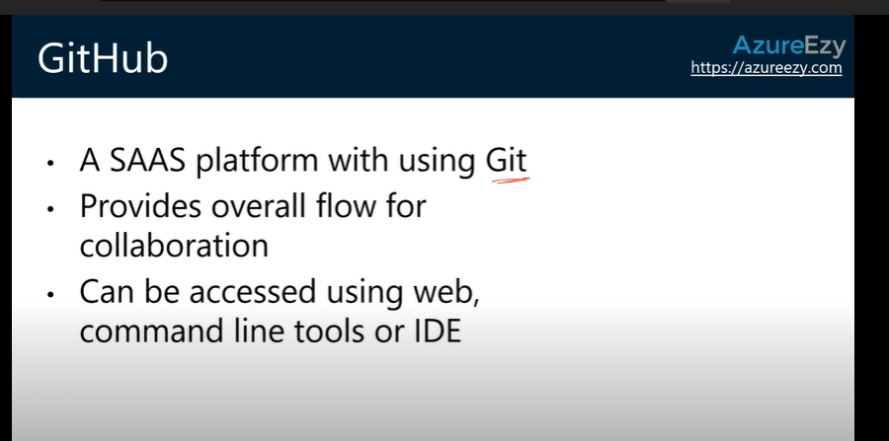

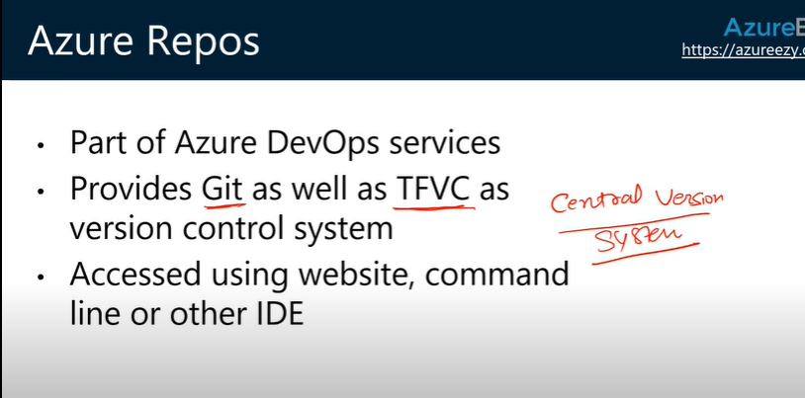

On September 10, 2018, Microsoft renamed Visual Studio Team Services (VSTS) to Azure DevOps Services. For moreinformation about this change, seeIntroducing Azure DevOp

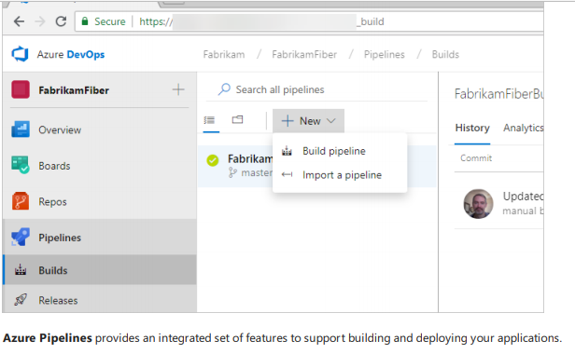

Service hooks enable you to complete tasks on other services when events happen within your project hosted on Azure DevOps. For example, you can send a push notification to your team's mobile devices when a build fails. You can also use service hooks in custom apps and services as a more efficient way to drive activities in your projects.

Differences in specific feature areas Although Azure DevOps Services is a hosted version of Azure DevOps Server, threesome differences between features. Some Azure DevOps Server features aren't supported in Azure DevOps Services. For example, Azure DevOps Services doesn't support integration with SQL Server Analysis Services to support reporting

Werecommend thatyou create organizations in Azure DevOps Services wherever you would createcollections in Azure DevOps Server.Thefollowing scenarios apply: You can purchase Azure DevOps Services users per organization - Paid users can access only the organization in which the payment is made. If you have users who need access to many organizations, Visual Studio subscriptions can bean attractive option. Visual Studio subscribers can beadded to any number of organizations at no charge. We'realso considering other ways to make access available to many organizations thatare grouped into a single organization. You currently have to administer organizations oneata time. This process can be cumbersome when you has many organizations.

You customize the work-tracking experience in two different ways, depending on the supported process model: For Azure DevOps Services, you usetheInheritance process model, which supports WYSIWYG customization. For Azure DevOps Server,you can choosetheInheritance process model or the On-premises XML process model, which supports customization through import or export of XML definition files for work-tracking objects. For Azure DevOps Server 2018 and earlier versions,you only haveaccess to the On-premises XML process model.

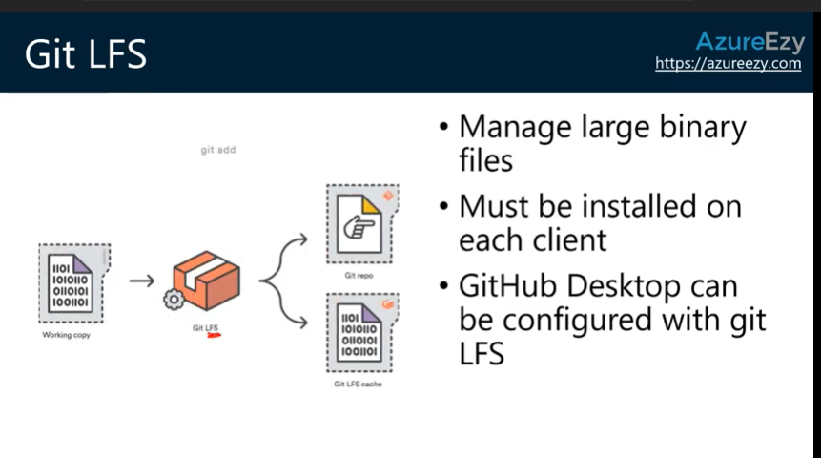

Lit has limitation. Git doesn’t support binary files, movie files and movie files.

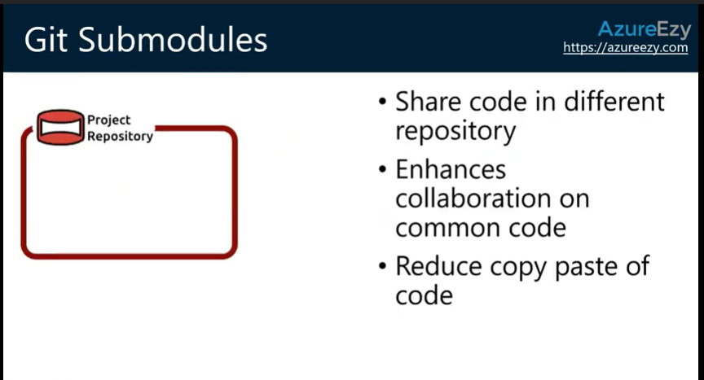

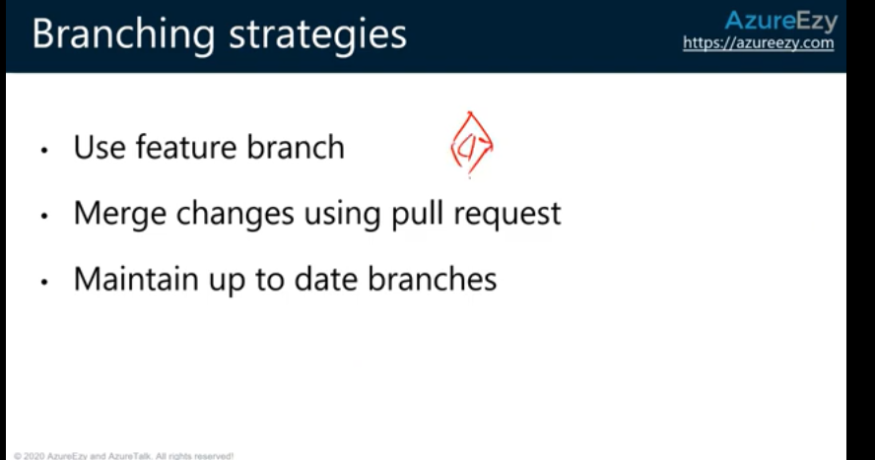

In branch Scernio we need to pull into master then we can identify it’s require to add or not. Isolation form.

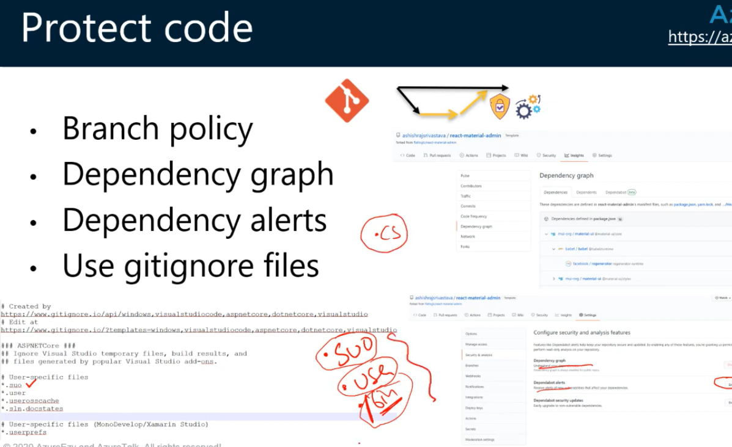

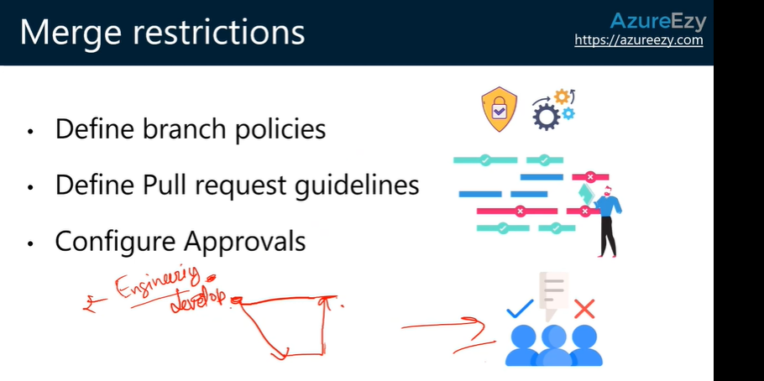

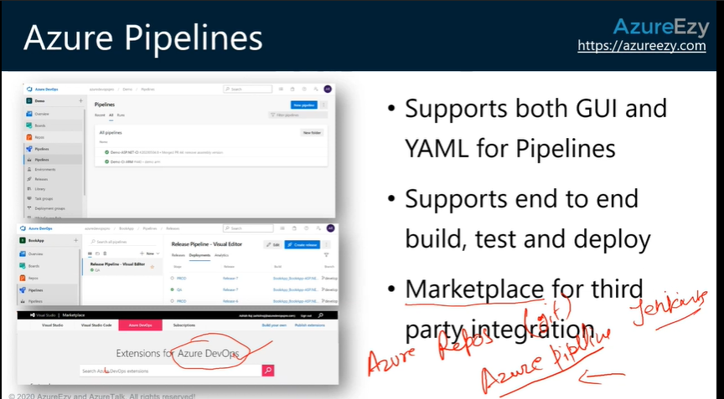

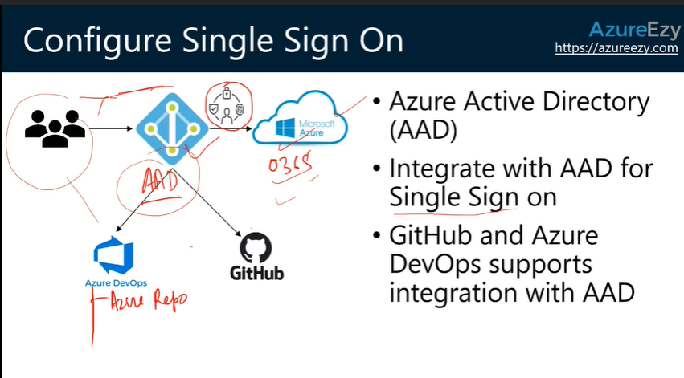

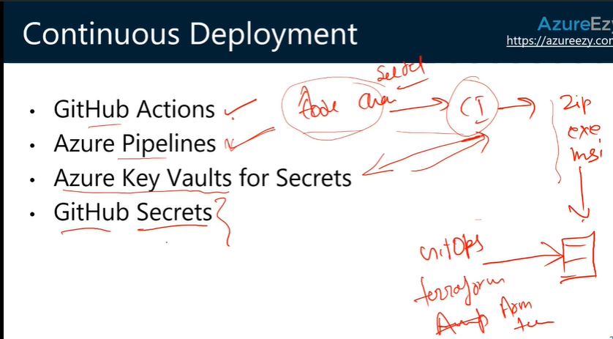

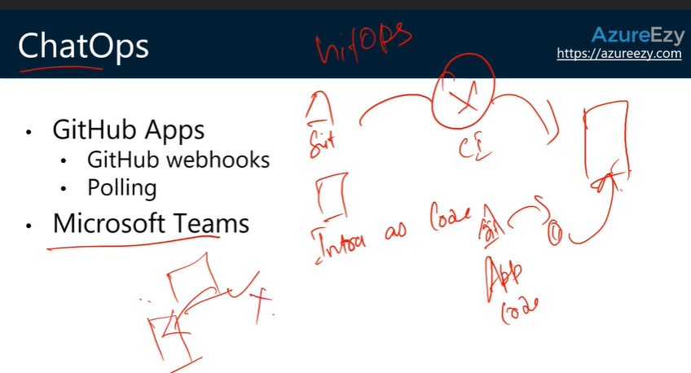

- Azure AD password hash synchronization. Here, the user's password is hashed twice and synchronized between the on-premises Active Directory and Azure AD. Users have the same credentials to access resources and applications both on-premises and in the cloud.
- Azure AD pass-through authentication. Here, an agent is installed on on-premises servers that authenticate against the on-premises Active Directory. When an Azure AD user account tries to authenticate, password authentication is handled on-premises through these servers and Active Directory.
- Federated authentication. Here, the authentication process is performed by an on-premises Active Directory Federation Services (AD FS) server that validates users' passwords. Use this authentication method if you want advanced measures like smart card-based authentication for users.
You use Azure B2C to manage customer identities. You use Azure AD B2B to invite external users to your tenant so that your staff can collaborate with them.

Azure Repos integerate with Git hub

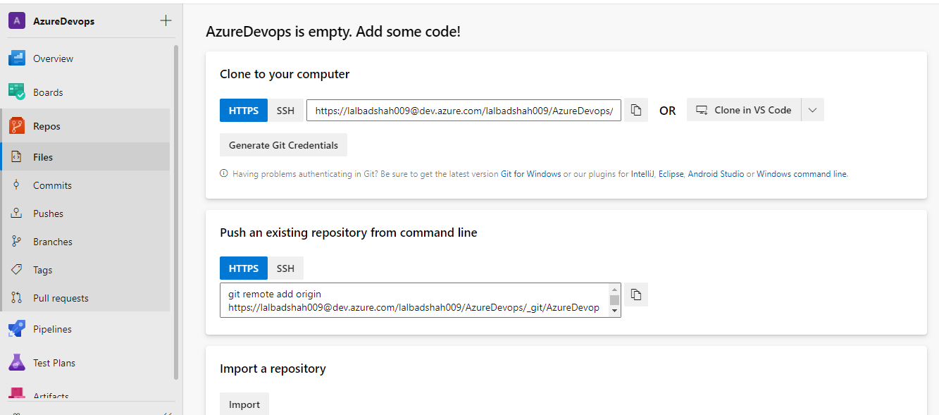

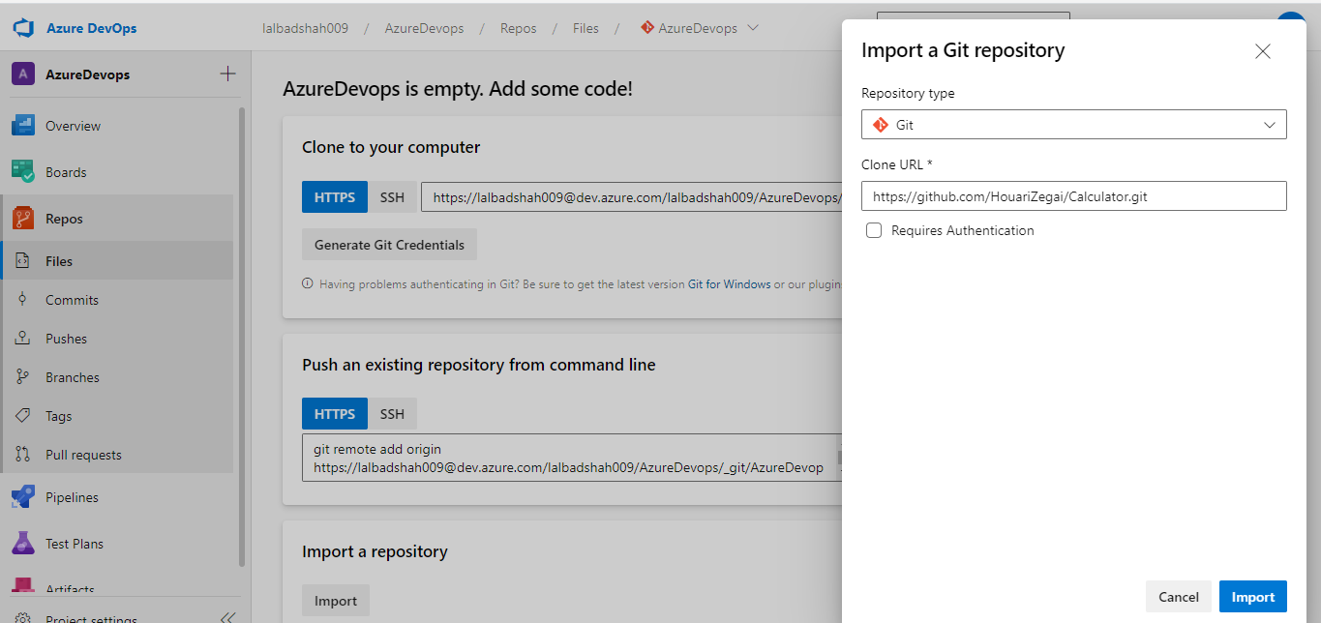

Import successful
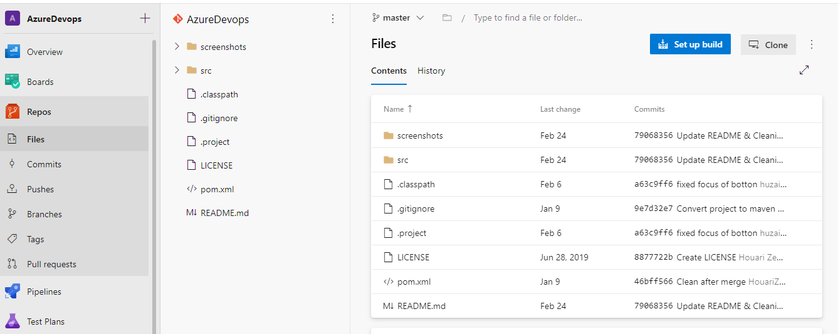

Visual Studio Cod- Shift+Ctrl+P
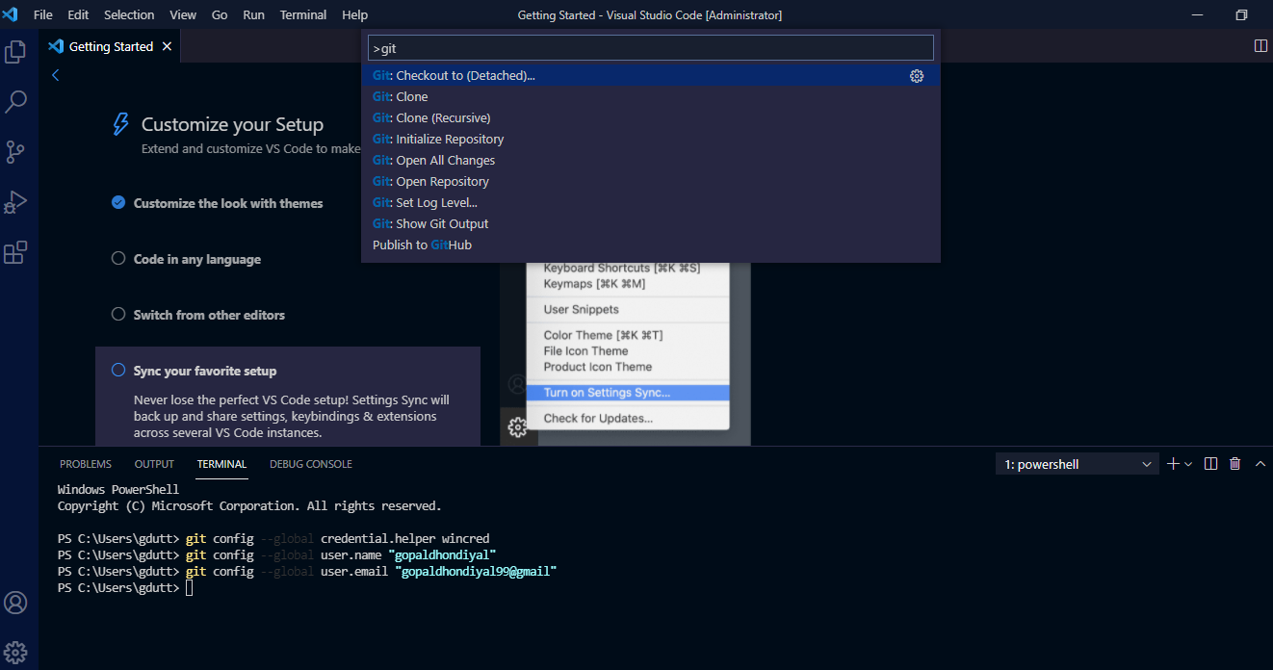

Paste URL
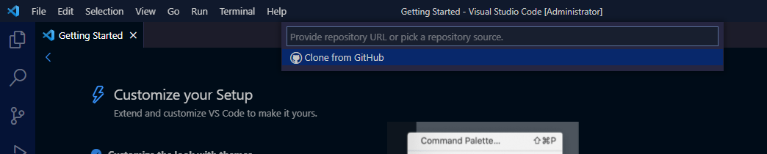

Paste the Link

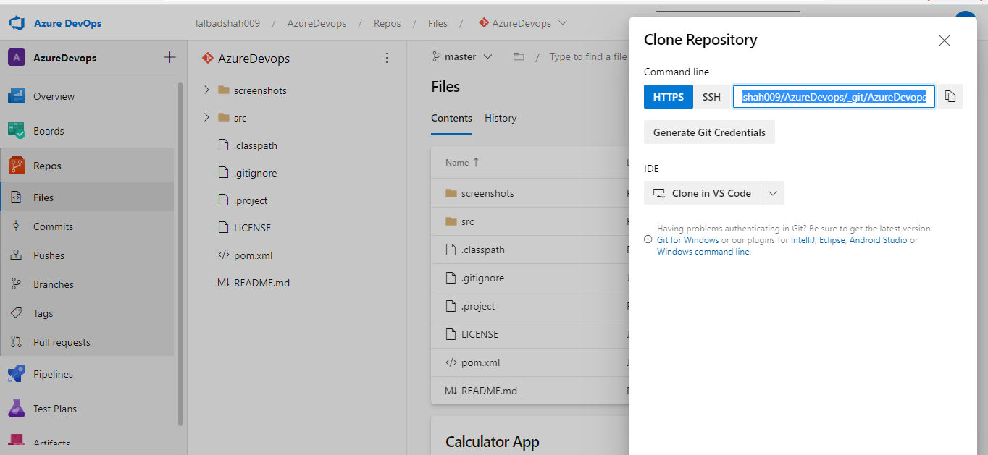
Select local path

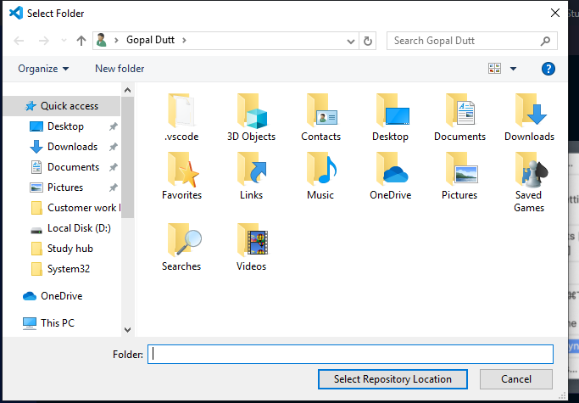

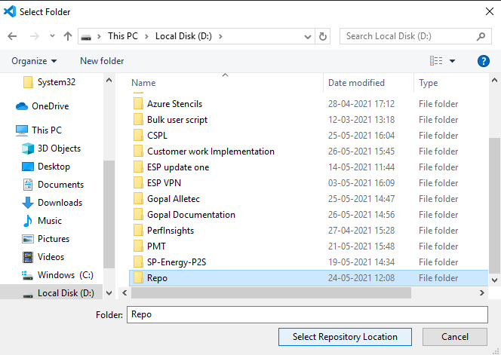

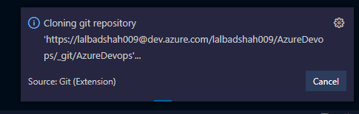

First change and got a pop-up
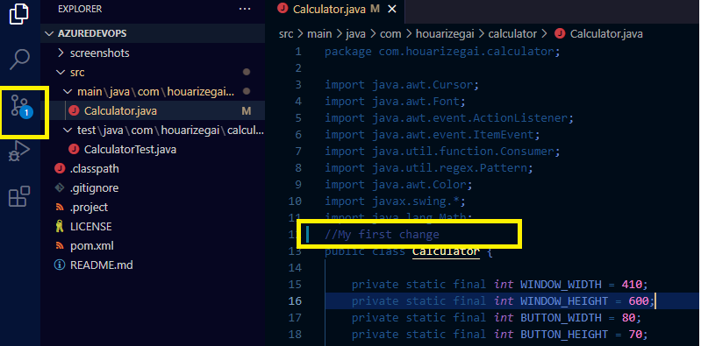
Click on commit

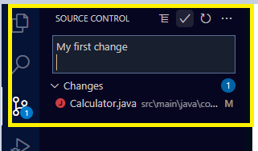
Click on Always

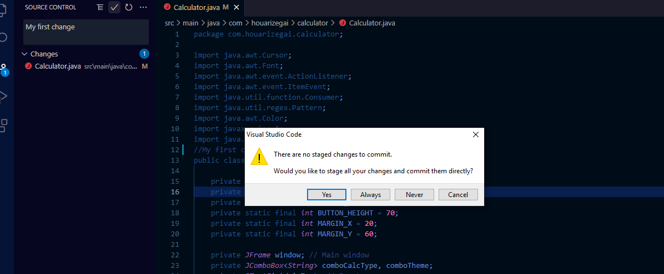
This is the change in local repo. If you want to replicate the change in Azure repo you need to click on Refresh

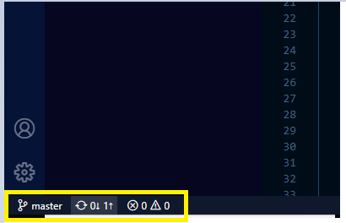
Click on OK

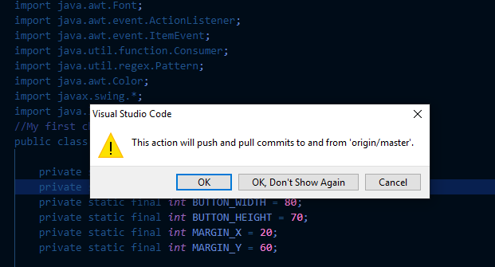

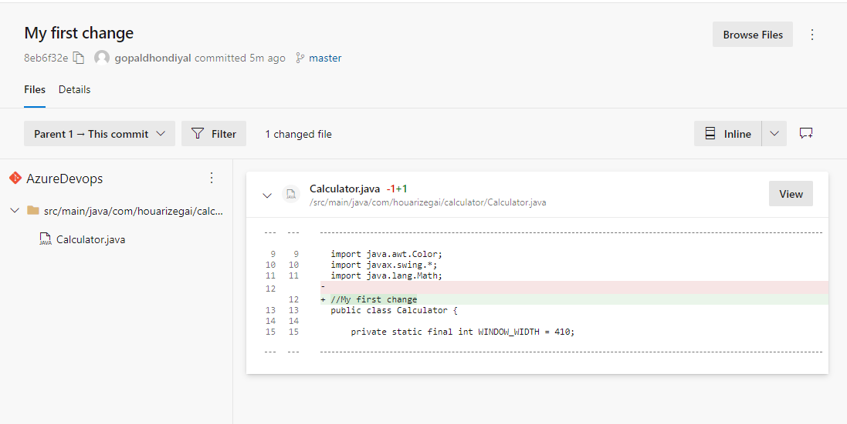

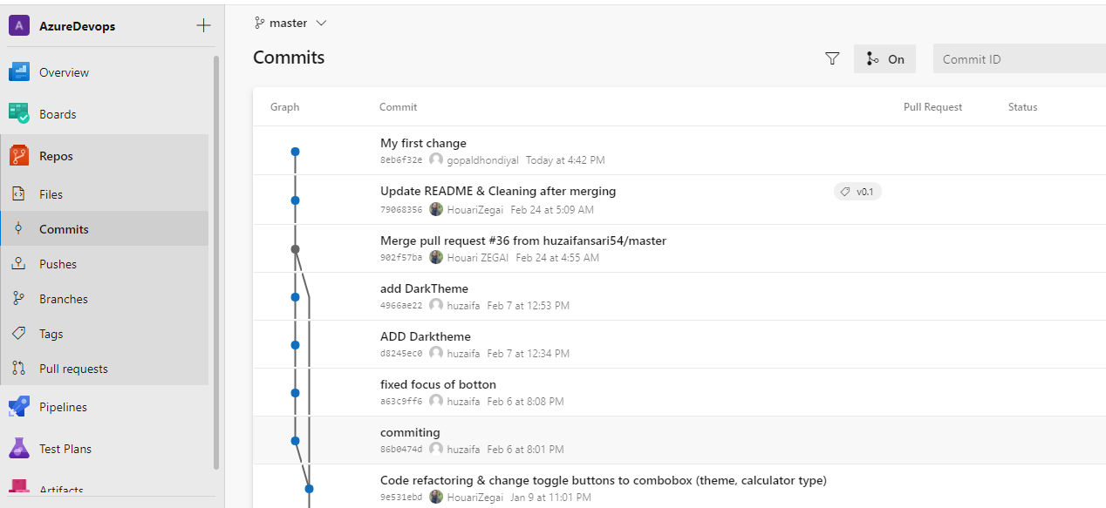

I have created two different change in different file. Now, I want to stage and push into Azure repos

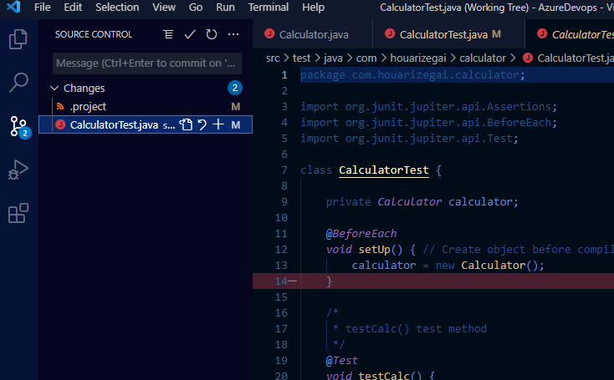

Click on three dot- Commit Staged
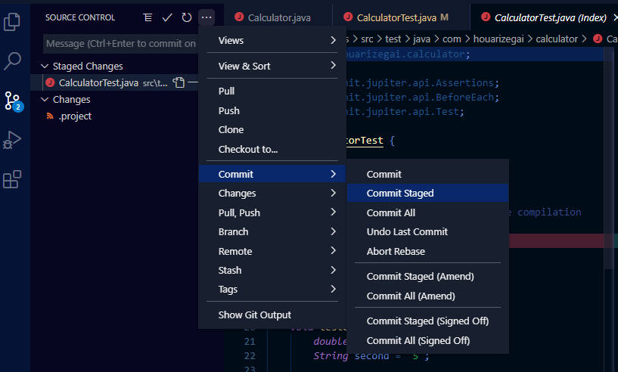

Type a message

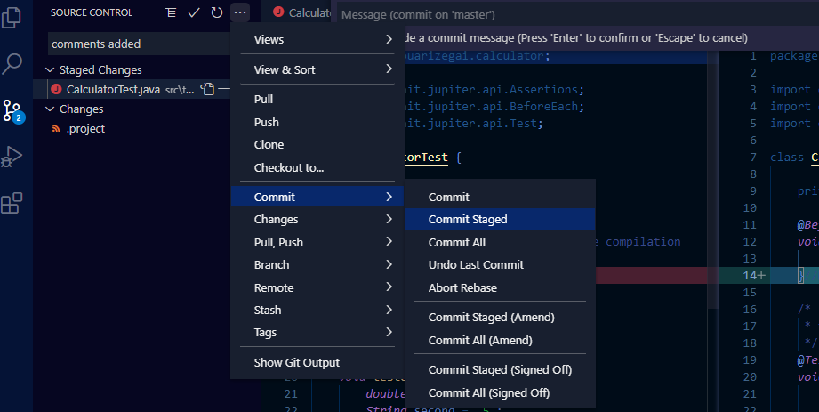
Updated

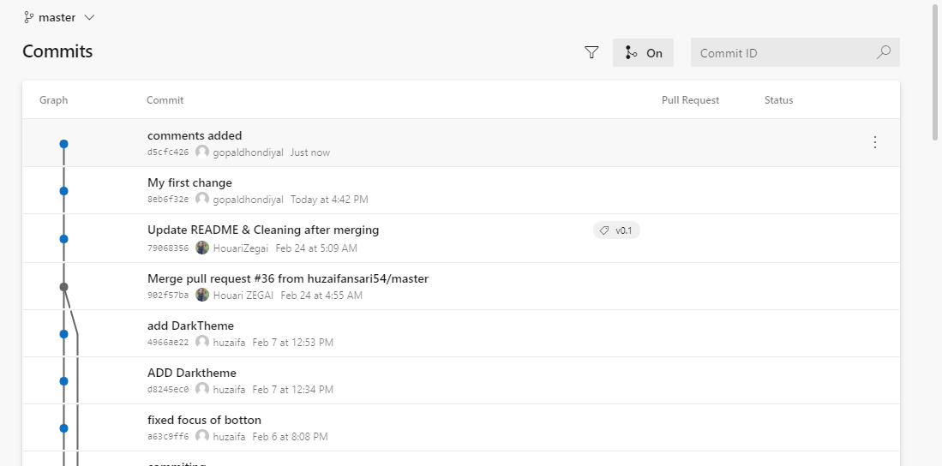

This is the way you can check time frame. When you have committed any change.

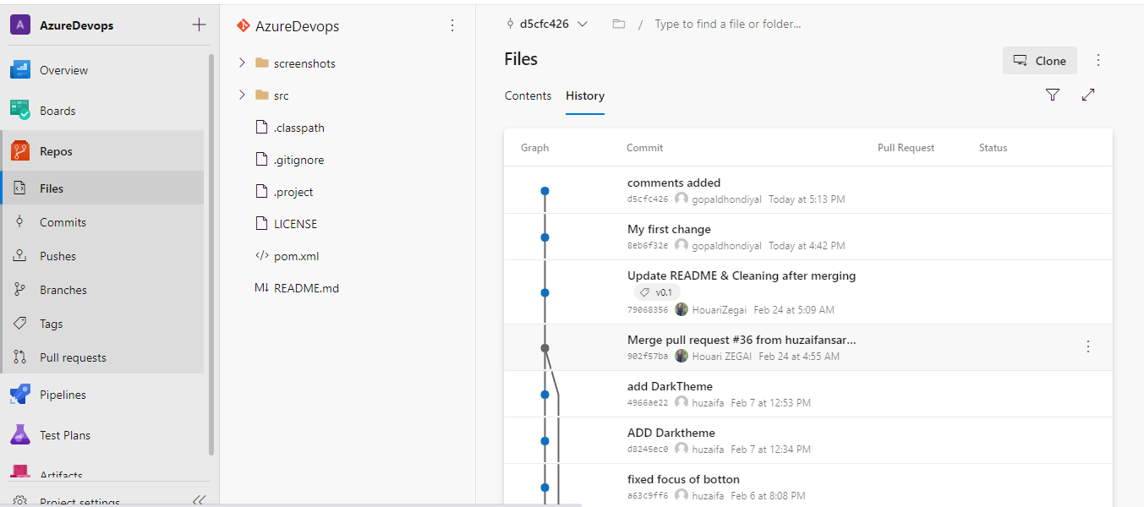

Create a New Branch

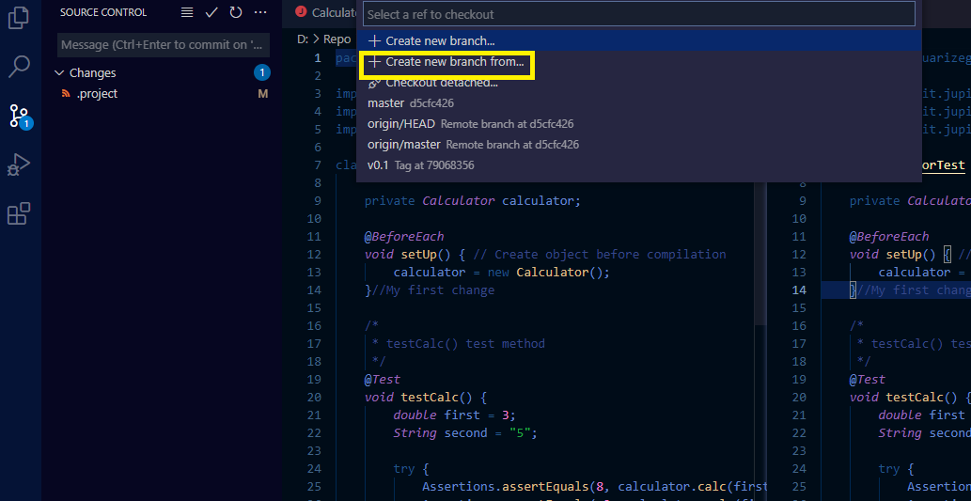

Branch Name Dev
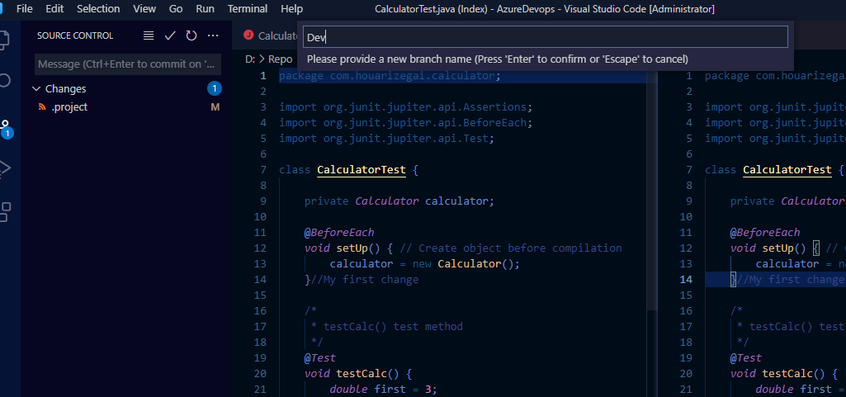

Click on Master
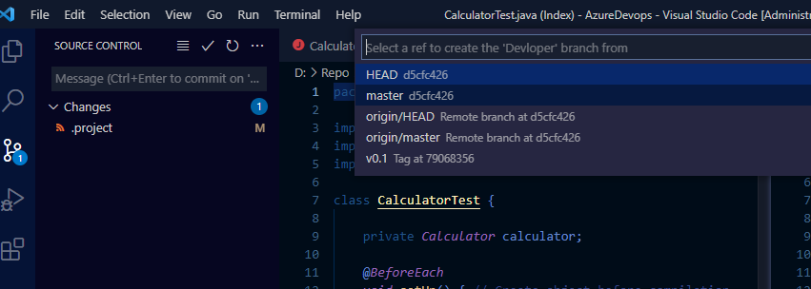

Create the new branch

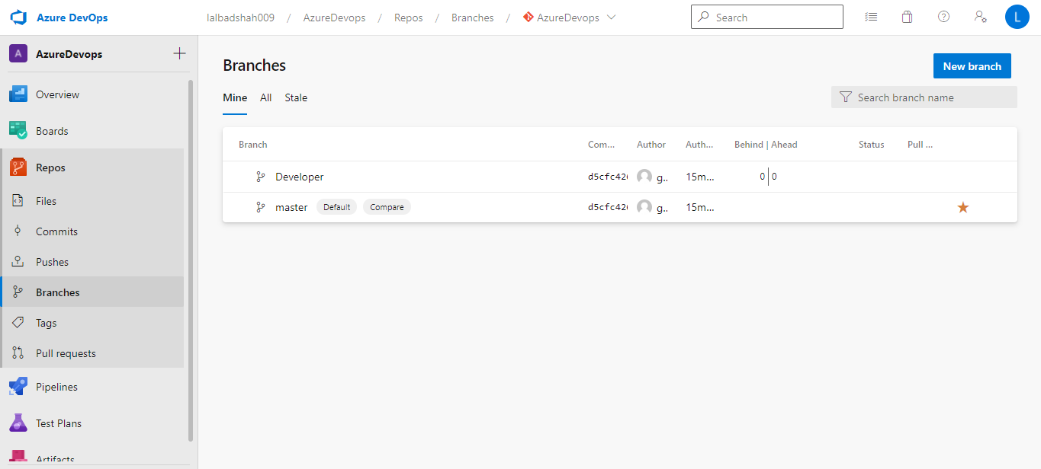

Delete the branch from Azure Repo
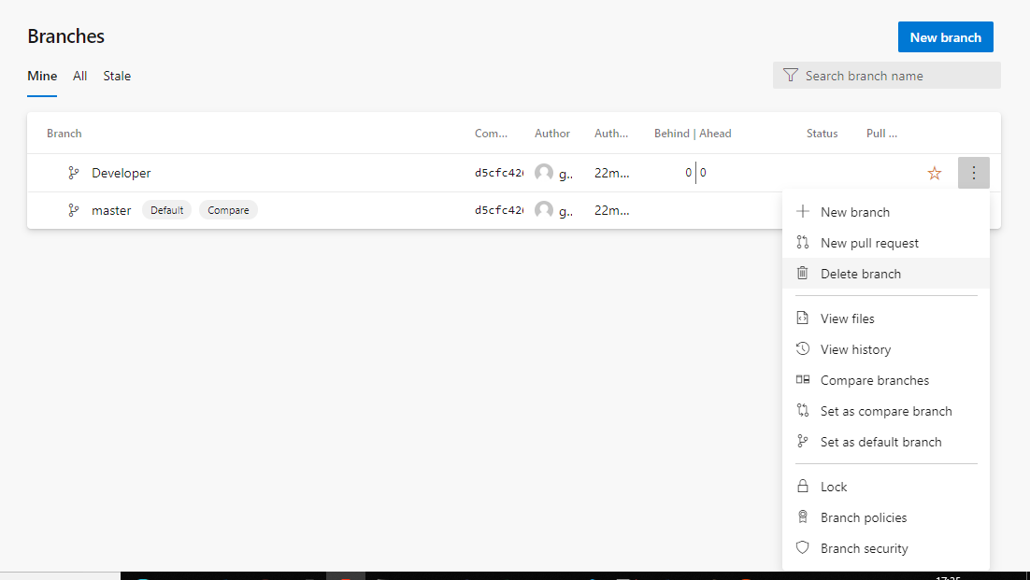

Press Ctrl+Shift+delete
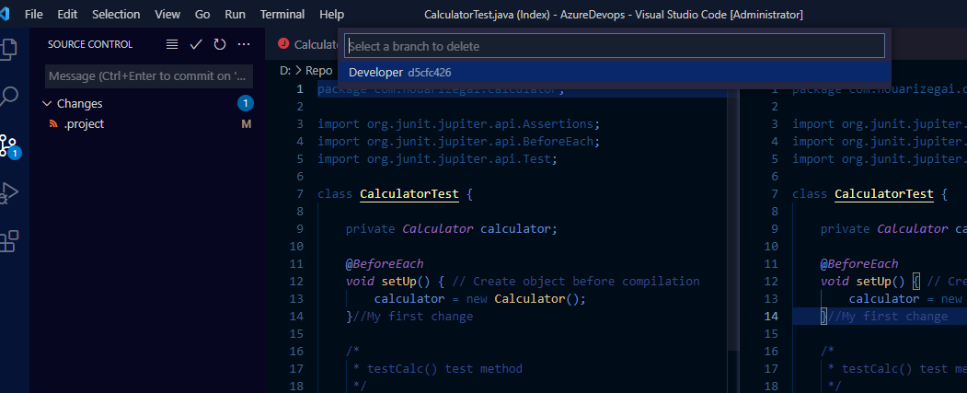

Create a New branch in Azure repo and integrate in Git
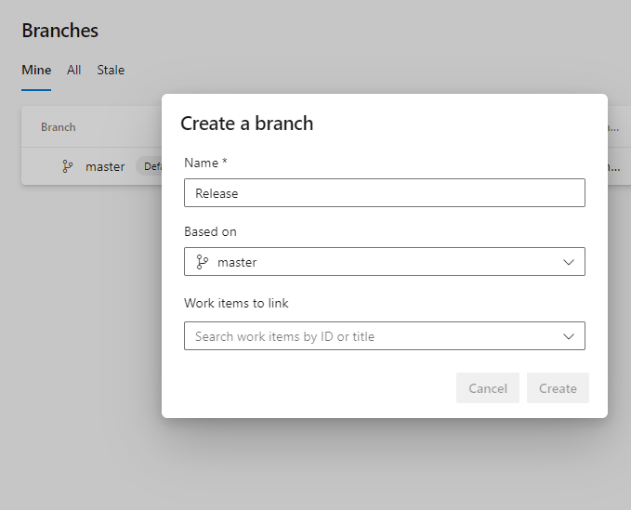

I have accidently deleted Release branch and now I am able to restored it.

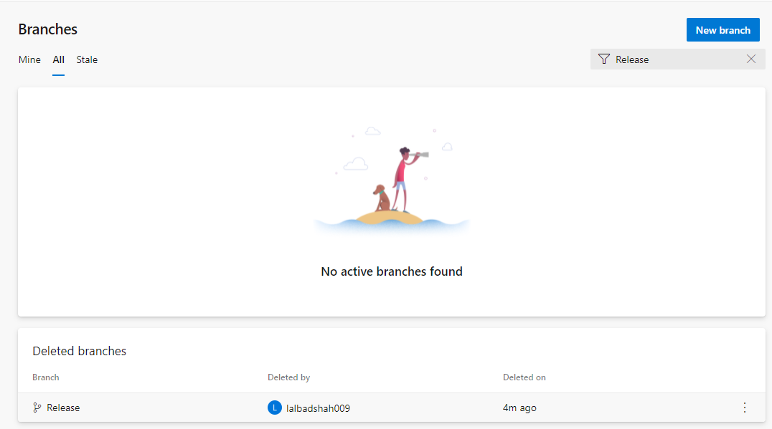

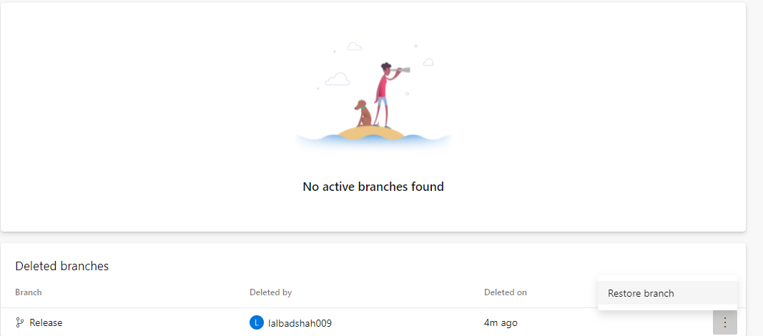

For security point of view. I can lock the branch
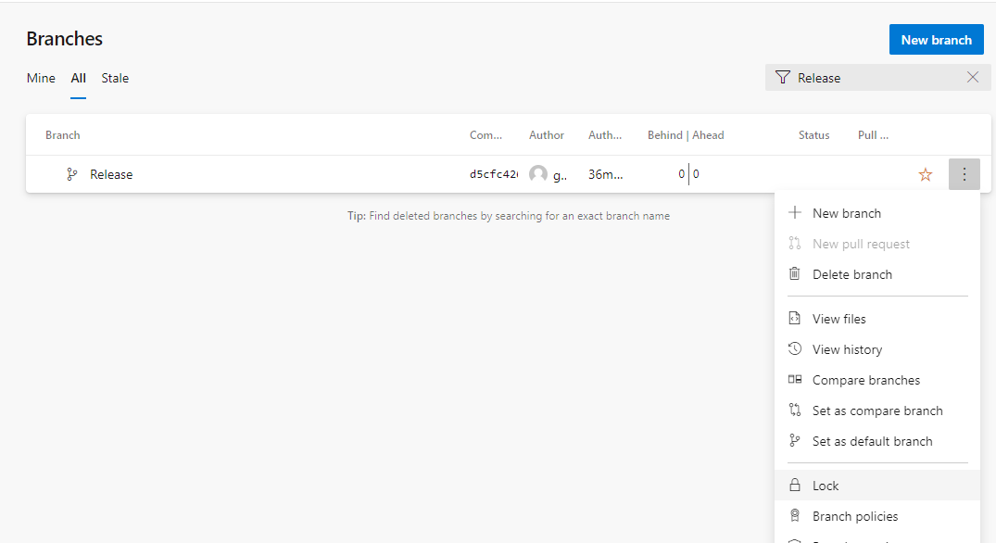

IT’s lock
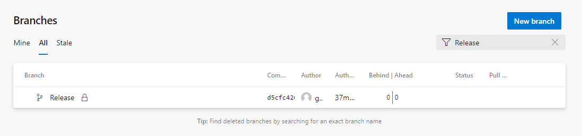
Create a New Azure Devops

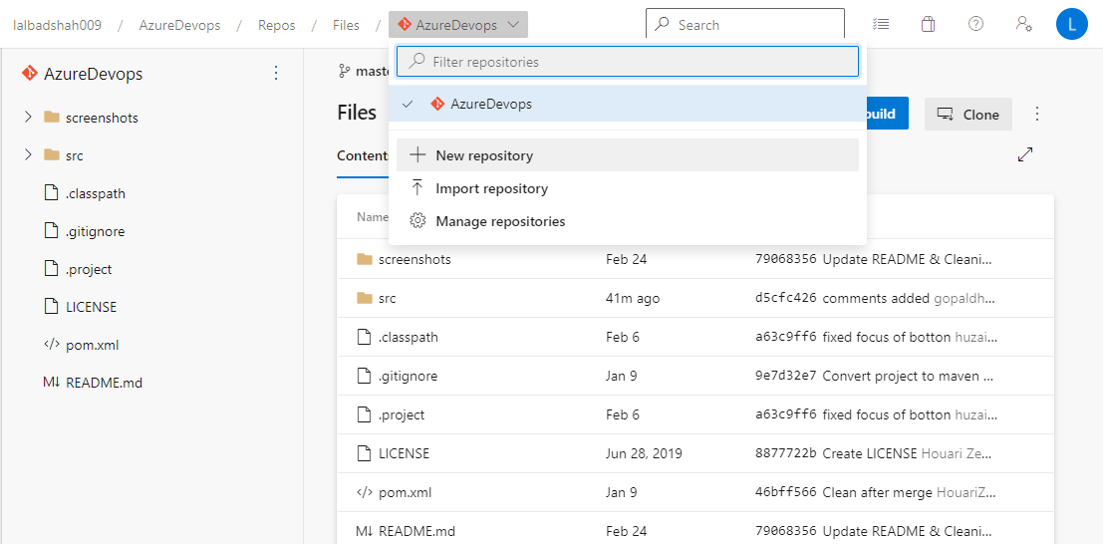
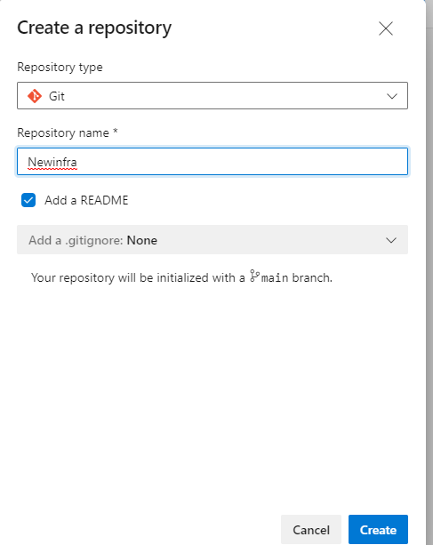

Integration of Azure Boards and Slack

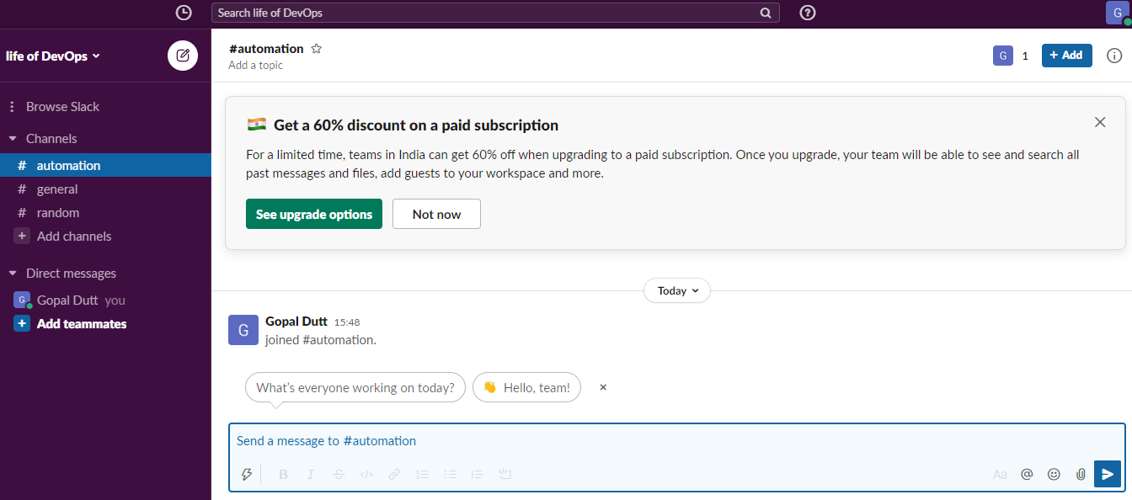

Click on Setting and Administration then go to Manage apps
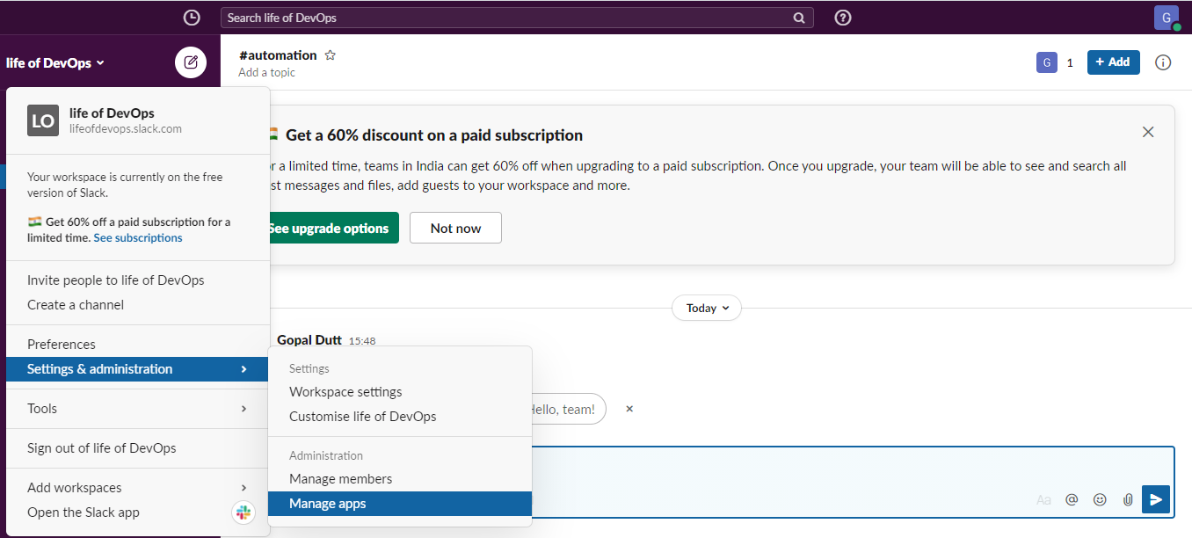

Search for Azure DevOps
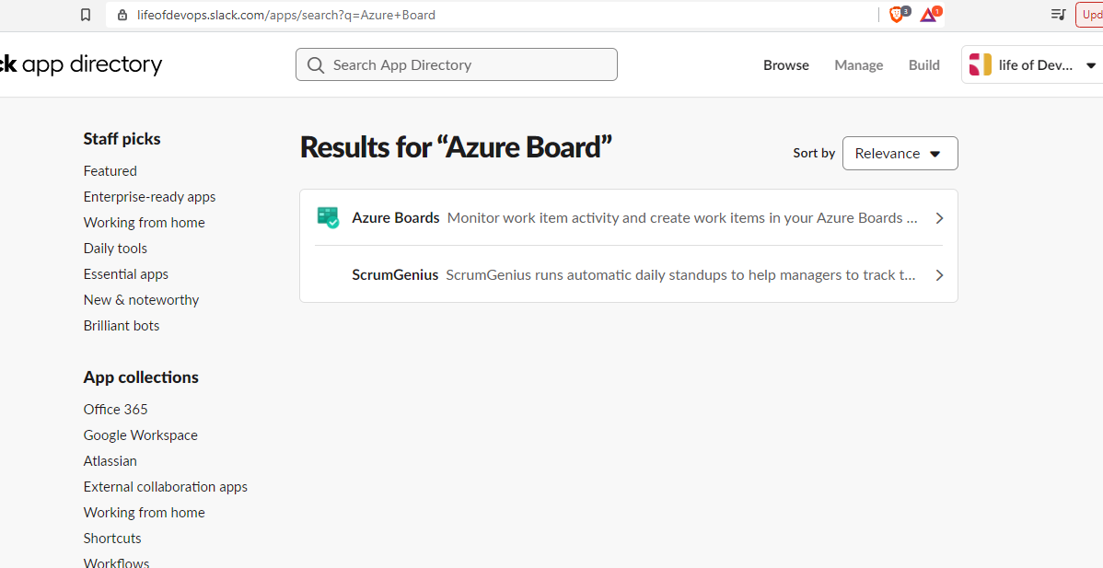
Add to Slack
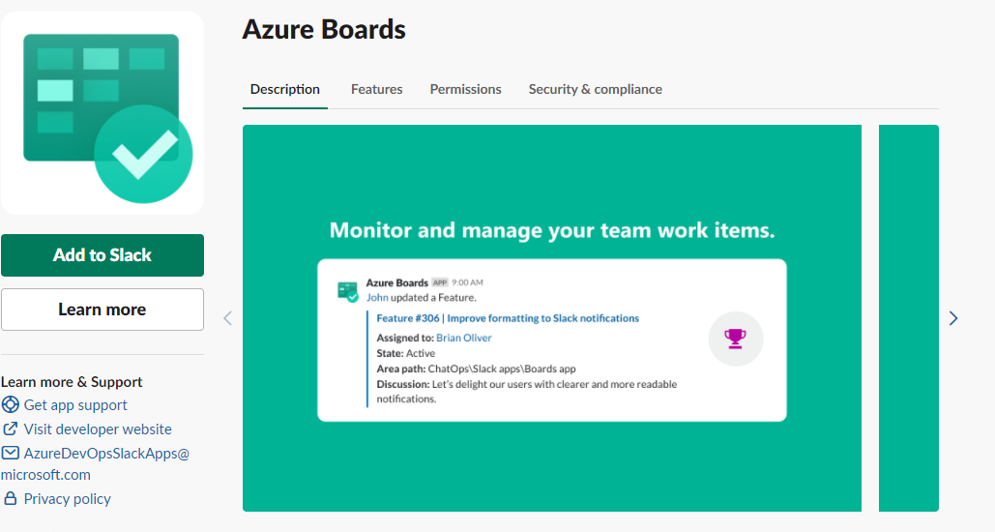
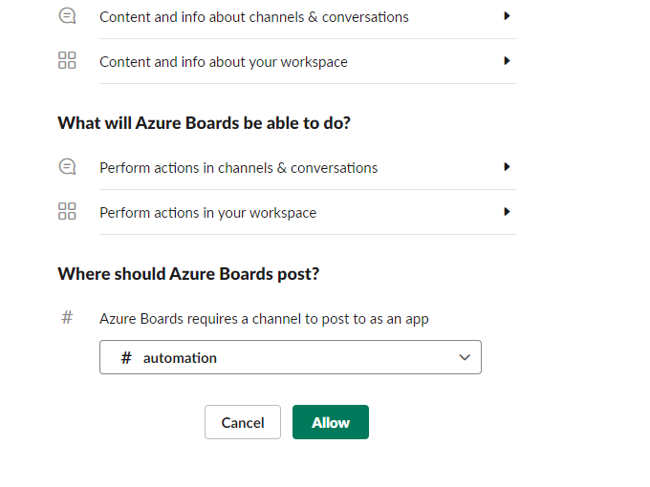
Copy azuredevops login in chat
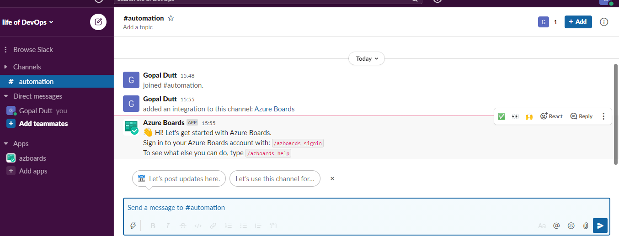

After put the azuredevops login you got the pop-up
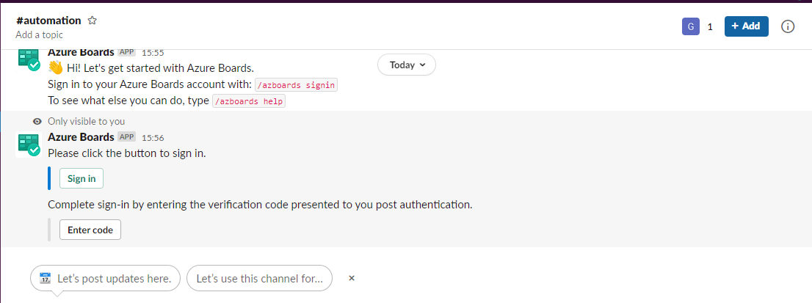

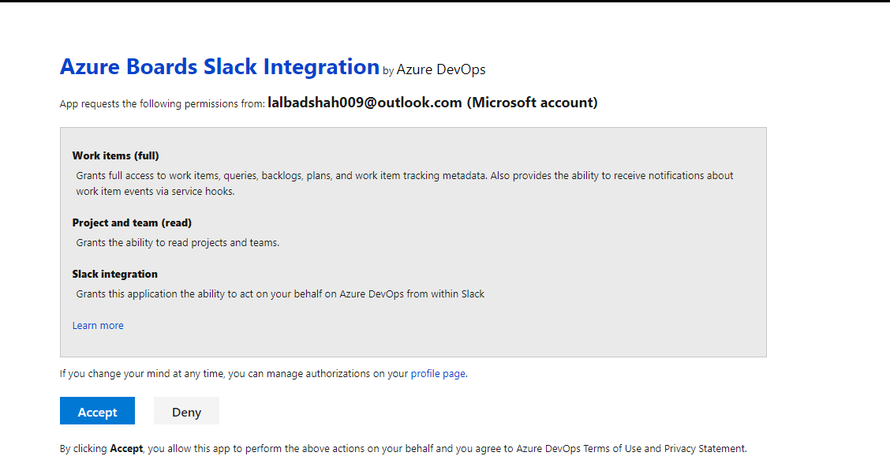

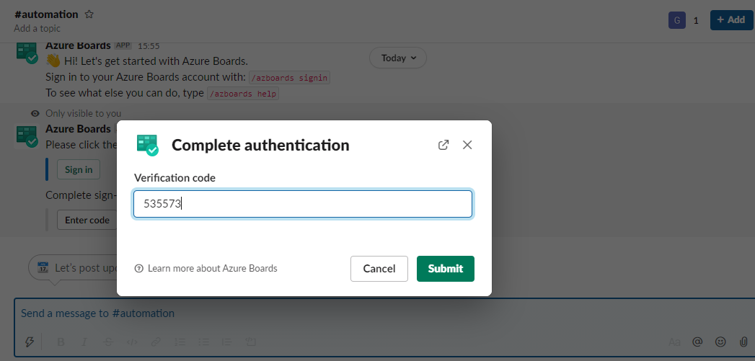

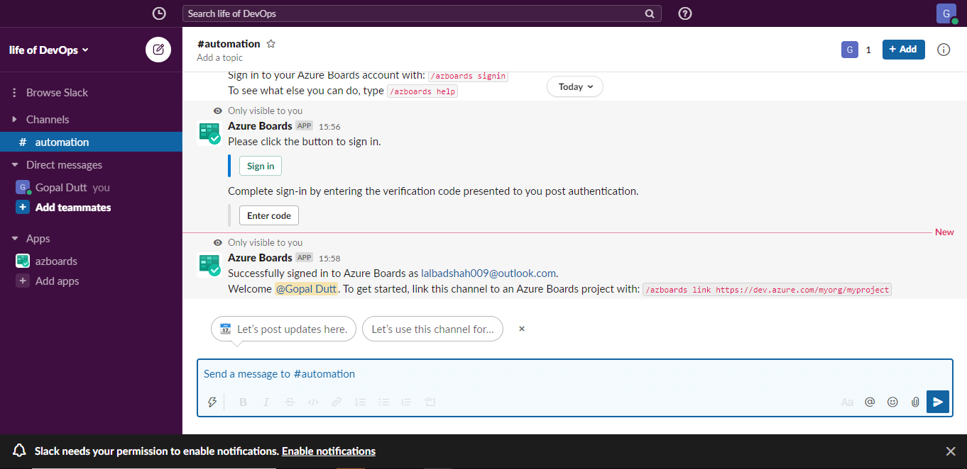
Put /azboards link paste the project link
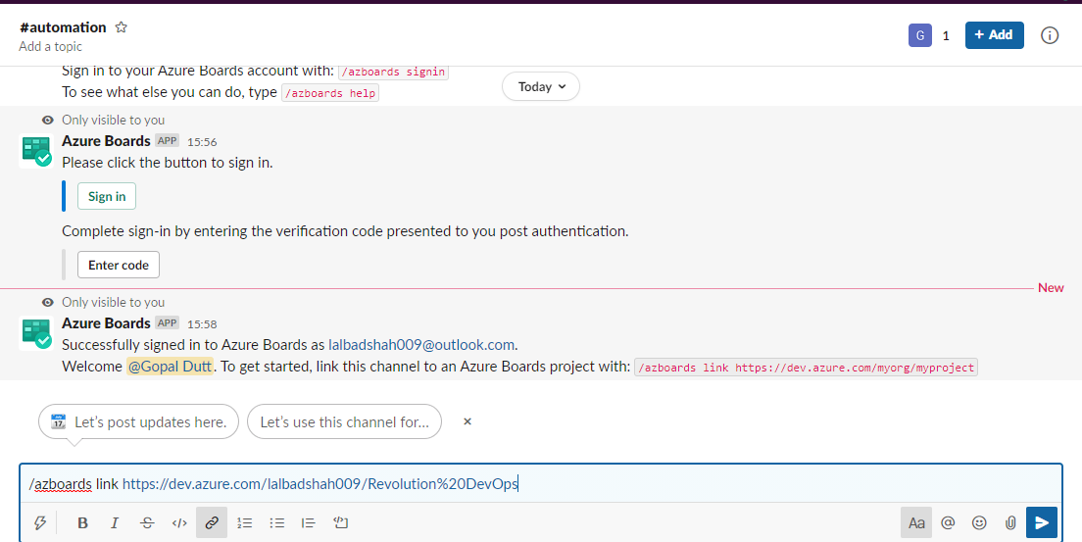

I added the subscription
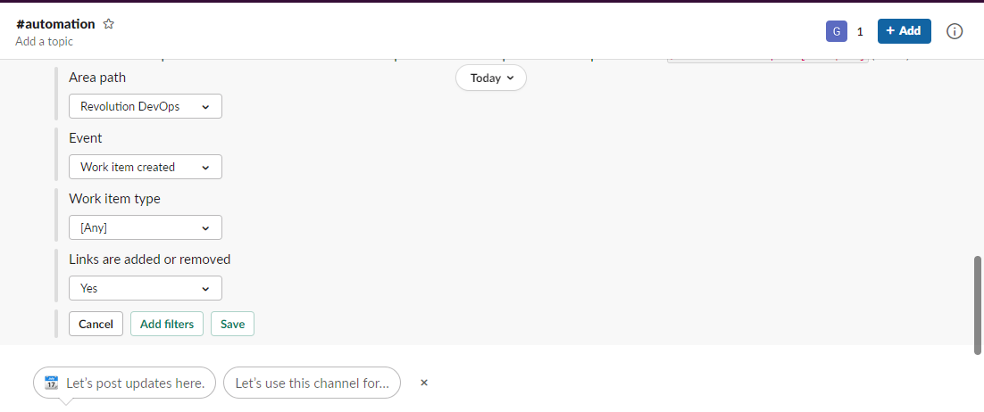

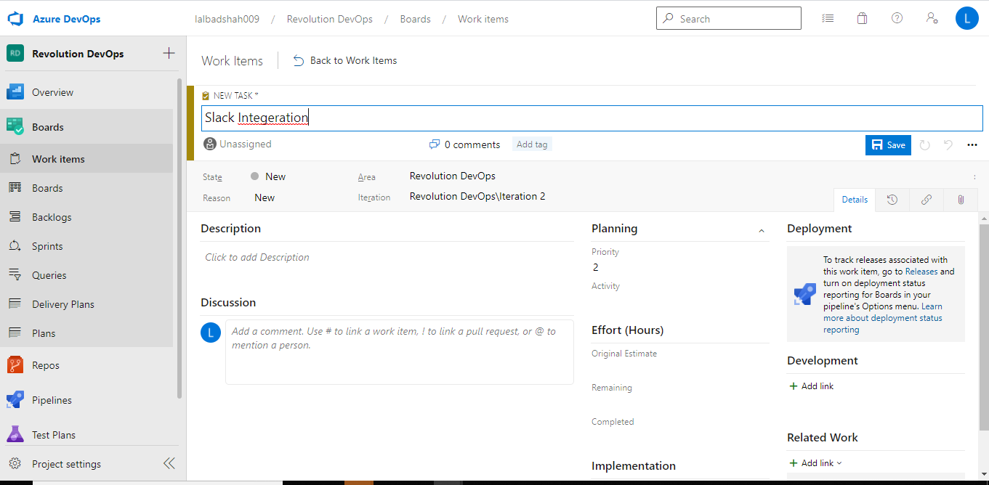

Slack intergeration done
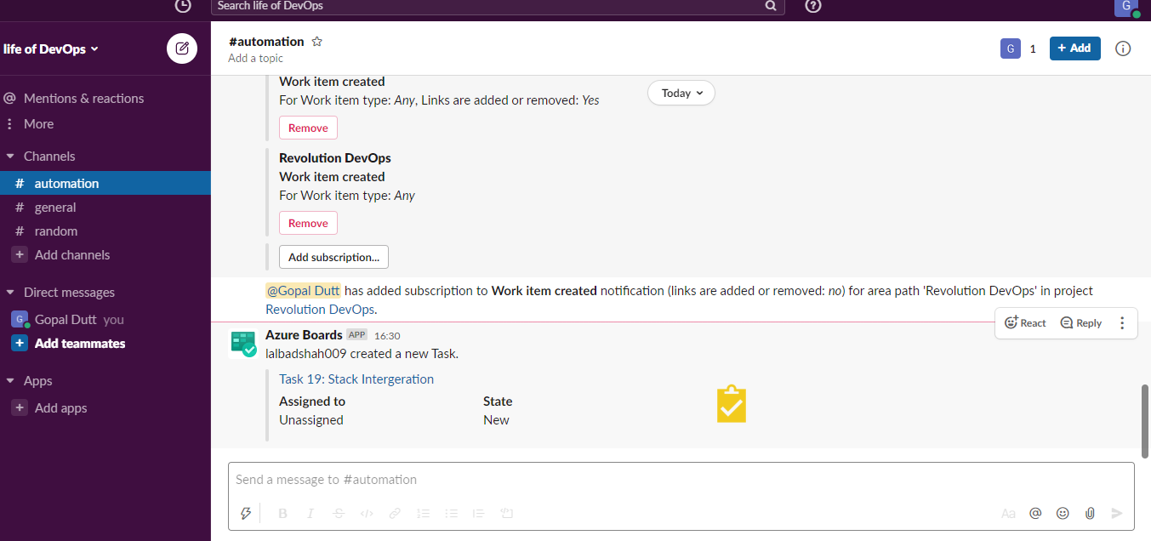

If you want to create a new user in Azure DevOps
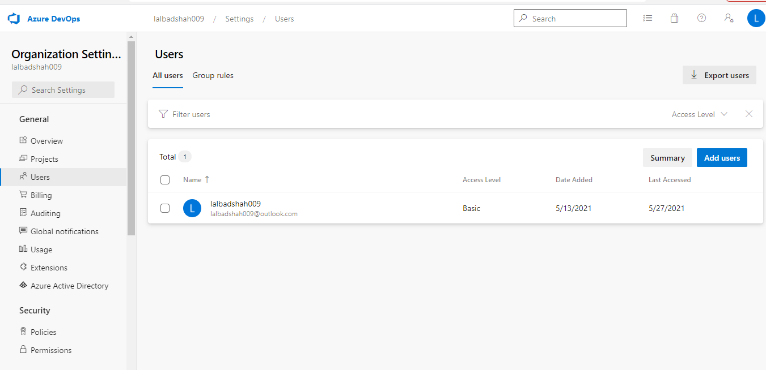

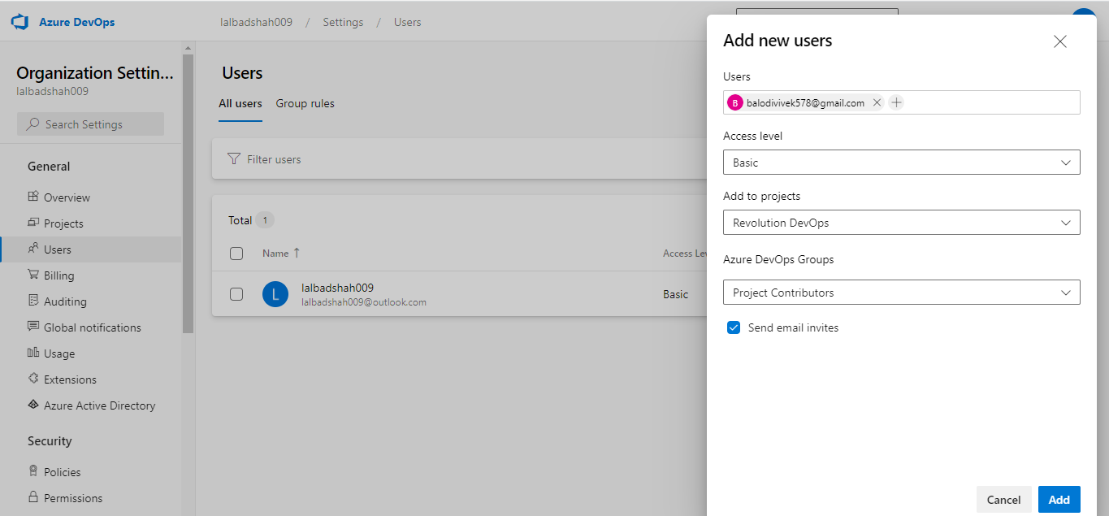

Intergeration of Azure AD and AzureDevOPs
Click on Azure Active Directory
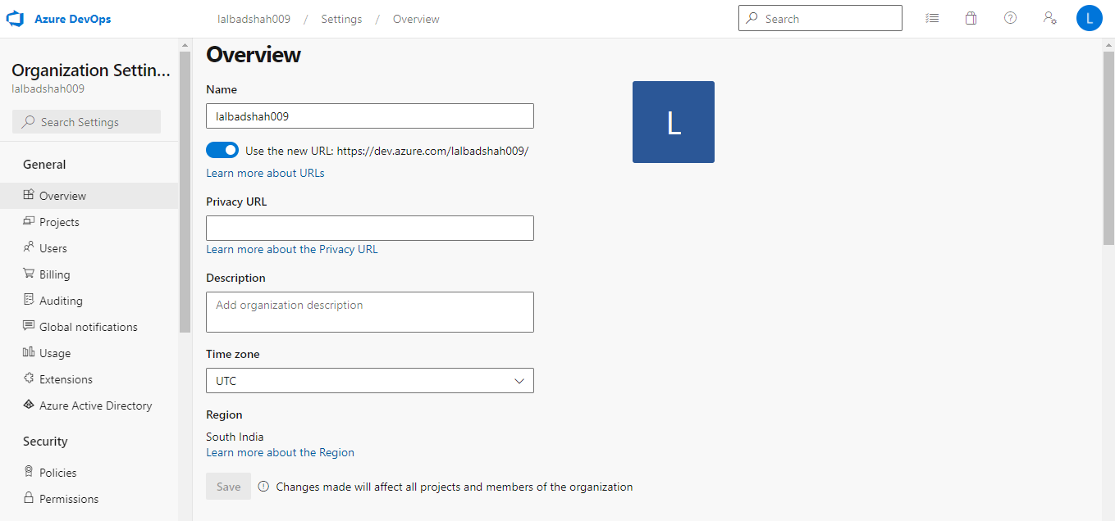
Connect Directory
